1. **INTRODUCTION**

Cloud computing is originated from earlier large-scale distributed computing technology. NIST defines Cloud computing as a model for enabling convenient, on demand network access to a shared pool of configurable computing resources (e.g.,networks, storage, applications and services) that can be rapidly provisioned and released with minimal management effort or service provider interaction”. In Cloud computing, both files and software are not fully contained on the user’s computer. File security concerns arise because both user’s application and program are residing in provider premises. The cloud provider can solve this problem by encrypting the files by using encryption algorithm. This paper presents a file security model to provide an efficient solution for the basic problem of security in cloud environment. In this model, hybrid encryption is used where files are encrypted and secured communication between users and the servers.

Data Security Issues:

* Due to openness and multi-tenant characteristics of the cloud, the traditional security mechanisms are no longer suitable for applications and data in cloud. Some of the issues are as following:
* Due to dynamic scalability, service and location transparency features of cloud computing model, all kinds of application and data of the cloud platform have no fixed infrastructure and security boundaries. In the event of security breach, it is difficult to isolate a particular resource that has a threat or has been compromised.
* According to service delivery models of Cloud computing, resources and cloud services may be owned by multiple providers. As there is a conflict of interest, it is difficult to deploy a unified security measure.
* Due to the openness of cloud and sharing virtualized resources by multitenant, user data may be accessed by other unauthorized users.

1. **LITERATURE SURVEY**
   1. **INTRODUCTION TO CLOUD STORAGE**

Cloud storage is a type of data storage where data is stored on remote servers that can be accessed over the internet. It allows users to store, access, and manage their data from anywhere with an internet connection, rather than storing data locally on a computer or device.

Cloud storage is provided by a cloud storage service provider, which maintains a network of servers and infrastructure for storing and managing data. Users can access their data on the cloud through a web interface or API, and can also use tools such as file syncing and backup software to automatically sync their local data with the cloud.

Cloud storage has become increasingly popular in recent years due to its convenience, flexibility, and scalability. It allows users to store large amounts of data without having to worry about physical storage limitations, and can be accessed from any device with an internet connection. It also provides a level of security and backup protection, as data is stored on multiple servers and can be easily recovered in the event of a disaster.

However, there are also some potential drawbacks to using cloud storage, including issues around security, privacy, and vendor lock-in. Users need to carefully consider the trade-offs and ensure that they choose a reputable and reliable cloud storage provider.

* 1. **OVERVIEW OF HYBRID CRYPTOGRAPHY**

Hybrid cryptography is a type of cryptography that combines elements of both symmetric-key and public-key cryptography. It is used to securely transmit data over networks, such as the internet, and is often used in combination with other security measures such as authentication and access control.

In symmetric-key cryptography, a single secret key is used to both encrypt and decrypt data. This means that the same key must be shared between the sender and receiver of the data in order to securely transmit it.

Public-key cryptography, on the other hand, uses a pair of keys: a public key that is used to encrypt data, and a private key that is used to decrypt it. The public key can be freely shared, while the private key is kept secret by the owner.

Hybrid cryptography combines these two approaches by using a combination of a public key and a secret key. The public key is used to securely transmit the secret key to the receiver, while the secret key is used to encrypt and decrypt the actual data. This allows for the benefits of both approaches: the security and flexibility of public-key cryptography for transmitting the key, and the efficiency and speed of symmetric-key cryptography for encrypting and decrypting the data.

Hybrid cryptography is widely used in a variety of applications, including secure messaging, online banking, and secure storage of files on cloud. It can provide a high level of security and is generally considered to be more secure than using either symmetric-key or public-key cryptography alone. However, it is important to choose strong algorithms and key lengths in order to ensure the security of the system.

* 1. **ALGORITHMS**

The Advanced Encryption Standard (AES) is a widely-used symmetric-key encryption algorithm that was adopted by the US government in 2002 as a standard for secure data encryption. It is a block cipher, which means that it operates on fixed-size blocks of data and uses the same secret key for both encryption and decryption.

AES is considered to be a very secure algorithm, with no known vulnerabilities or attacks that can effectively break it. It is fast and efficient, making it well-suited for use in high-performance applications such as secure storage of files on cloud. It is also widely supported by a range of hardware and software implementations, making it easy to use and integrate into various systems.

The Secure Hash Algorithm (SHA) is a widely-used cryptographic hash function that is used to create a fixed-size message digest (also known as a hash) from input data. It is a one-way function, which means that it is computationally infeasible to recreate the original data from the hash.

There are several different versions of SHA, including SHA-1, SHA-2, and SHA-3, with each successive version offering improvements in terms of security and performance. SHA-1 is no longer considered to be secure due to the existence of collision attacks, while SHA-2 and SHA-3 are considered to be more secure and are widely used in a variety of applications.

In the context of hybrid cryptography for secure storage of files on cloud, the Advanced Encryption Standard (AES) is typically used to encrypt the actual data, while a version of SHA (such as SHA-2 or SHA-3) is used to create a message digest of the data for integrity checking. The secret key for the AES encryption is transmitted using public-key cryptography, while the message digest is used to verify that the data has not been tampered with during transmission. This combination of algorithms allows for both secure transmission and verification of the integrity of the data.

* 1. **BENEFITS AND DRAWBACKS OF HYBRID CRYPTOGRAPHY**

There are several benefits to using hybrid cryptography for secure storage of files on cloud, including:

Security: Hybrid cryptography provides a high level of security by combining the strengths of both symmetric-key and public-key cryptography. It allows for the efficient encryption and decryption of data using a secret key, while also providing a secure means of transmitting the key using public-key cryptography.

Performance: Hybrid cryptography can provide good performance, especially when compared to pure public-key cryptography, which can be slower and more resource-intensive. This makes it well-suited for use in high-performance applications such as secure storage of files on cloud.

Flexibility: Hybrid cryptography allows for the flexibility of public-key cryptography, which allows for the secure transmission of the secret key without requiring a secure channel for key exchange. This makes it easier to use in a variety of situations, such as when the sender and receiver do not have a pre-existing secure channel.

However, there are also some potential drawbacks to using hybrid cryptography, including:

Complexity: Hybrid cryptography can be more complex to implement and manage than either symmetric-key or public-key cryptography alone. It requires the use of both types of keys and algorithms, which can increase the complexity of the system.

Key management: Proper key management is essential for the security of any cryptographic system, and this is especially true for hybrid cryptography. The secret key must be carefully managed and protected, and the public key must be securely transmitted to the intended recipient.

Cost: Hybrid cryptography can be more expensive than other types of cryptography due to the need for both symmetric-key and public-key algorithms and infrastructure. This can make it less suitable for some applications or budgets.

Overall, the benefits and drawbacks of using hybrid cryptography for secure storage of files on cloud will depend on the specific needs and requirements of the application. It is important to carefully consider these trade-offs and choose the appropriate cryptography based on the specific requirements of the system.

* 1. **CASE STUDIES AND REAL WORLD EXAMPLES**

Case studies and real-world examples: This section would provide examples of how hybrid cryptography with AES and SHA has been used in real-world scenarios to secure the storage of files on cloud.

Here are some examples of real-world scenarios where hybrid cryptography with AES and SHA has been used to secure the storage of files on cloud:

Online banking: Many online banking systems use hybrid cryptography to secure the transmission of sensitive financial data over the internet. This typically involves the use of AES to encrypt the data, and SHA to create a message digest for integrity checking. The secret key for the AES encryption is transmitted using public-key cryptography, allowing for secure transmission of the data without requiring a pre-existing secure channel.

Secure messaging: Hybrid cryptography is commonly used in secure messaging applications, such as end-to-end encrypted email and chat systems. These systems use AES to encrypt the actual messages, and public-key cryptography to securely transmit the secret key. SHA is often used to create a message digest for integrity checking, ensuring that the messages have not been tampered with during transmission.

Cloud storage: Hybrid cryptography is also used in many cloud storage systems to secure the storage and transmission of sensitive data. This typically involves the use of AES to encrypt the data, and SHA to create a message digest for integrity checking. The secret key for the AES encryption is transmitted using public-key cryptography, allowing for secure transmission of the data to and from the cloud.

Overall, hybrid cryptography with AES and SHA has been widely used in a variety of real-world scenarios to secure the storage and transmission of sensitive data, including online banking, secure messaging, and cloud storage. It provides a high level of security and is generally considered to be a reliable and effective approach for these types of applications.

* 1. **FUTURE DIRECTIONS AND LIMITATIONS**

There are several potential future directions for research in the area of hybrid cryptography, including:

Improved algorithms: Researchers are constantly working to develop more secure and efficient algorithms for use in cryptography, including both symmetric-key and public-key algorithms. This could lead to the development of new hybrid cryptography systems that offer improved security and performance.

Quantum-resistant cryptography: As quantum computers become more powerful, they may eventually be able to break some of the algorithms currently used in cryptography, including some used in hybrid cryptography systems. Researchers are working on developing new quantum-resistant algorithms that will be able to withstand the power of quantum computers, ensuring the continued security of cryptographic systems.

Improved key management: Proper key management is essential for the security of any cryptographic system, and this is especially true for hybrid cryptography. Researchers are exploring new approaches to key management that can improve the security and efficiency of hybrid cryptography systems.

There are also several potential limitations and challenges that need to be addressed in the use of hybrid cryptography, including:

Complexity: Hybrid cryptography can be more complex to implement and manage than other types of cryptography, which can make it more difficult to use in some situations. This complexity can also increase the risk of errors or vulnerabilities being introduced into the system.

Cost: Hybrid cryptography can be more expensive than other types of cryptography due to the need for both symmetric-key and public-key algorithms and infrastructure. This can make it less suitable for some applications or budgets.

Key management: Proper key management is essential for the security of any cryptographic system, and this is especially true for hybrid cryptography. Ensuring the secure transmission and protection of the secret key is critical to the security of the system.

Overall, there are many ongoing and potential future research directions in the area of hybrid cryptography, as well as a number of challenges and limitations that need to be addressed in order to ensure the continued security and effectiveness of these systems.

1. **System Analysis:**

**3.1 EXISTING SYSTEM:**

In Existing System we use a straightforward integration method. In a straightforward integration method Storing data in a third party’s cloud system causes serious concern on data confidentiality. In order to provide strong confidentiality for messages in storage servers, a user can encrypt messages by a cryptographic method before applying an erasure code method to encode and store messages. When he wants to use a message, he needs to retrieve the

Codeword symbols from storage servers, decode them, and then decrypt them by using cryptographic keys. General encryption schemes protect data confidentiality, but also limit the functionality of the storage system because a few operations are supported over encrypted data. A decentralized architecture for storage systems offers good scalability, because a storage server can join or leave without control of a central authority.

**3.2 Drawbacks of Existing System:**

* The user can perform more computation and communication traffic between the user and storage servers is high.
* The user has to manage his cryptographic keys otherwise the security has to be broken.
* The data storing and retrieving, it is hard for storage servers to directly support other functions.

**3.3 PROPOSED SYSTEM:**

In our proposed systemwe address the problem of forwarding data to another user by storage servers directly under the command of the data owner. We consider the system model that consists of distributed storage servers and key servers. Since storing cryptographic keys in a single device is risky, a user distributes his cryptographic key to key servers that shall perform cryptographic functions on behalf of the user. These key servers are highly protected by security mechanisms.

                            Here Storage system has allocates by different data container. Once owner uploads the data with AES encryption mechanism, system again takes the data and makes Secure Data segregation process. All the data pieces will be save in different location in cloud storage. Here public distributor monitors all the data and corresponding positions where it is saved. When a proper client asking the data, cloud system will provide the data in reversible manner. So our system will prevent our data from both Inside and Outside attackers.

**3.4 Advantages of Proposed system:**

* Tight integration of encoding, encryption, and forwarding makes the storage system efficiently meet the requirements of data robustness, data confidentiality, and data forwarding.
* The storage servers independently perform encoding and re-encryption process and the key servers independently perform partial decryption process.
* More flexible adjustment between the number of storage servers and robustness.

**3.5 System Requirements:**

**3.5.1 HARDWARE REQUIREMENTS :**

* Main Processor               : 2GHz
* Ram                                : 512 MB (min)
* Hard Disk                       : 80 GB

**3.5.2 SOFTWARE REQUIREMENTS :**

* Language          : Java
* Web Server       : Tomcat 6
* Operating System : Windows 7 32 Bit

1. **System Design:**

**4.1 System architecture:**

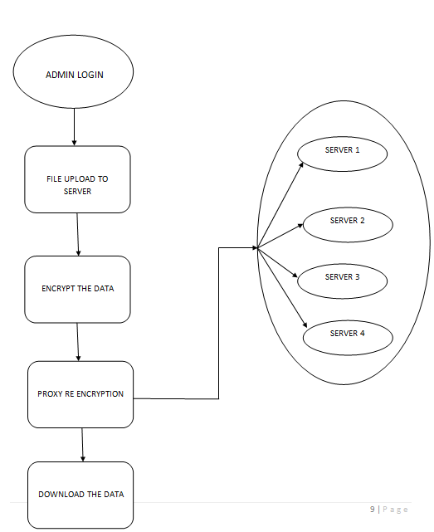

**4.2 Modules (List & Description):**

1. Registration
2. Sharing Data
3. Secure Cloud Storage
4. Proxy re-encryption
5. Data retrieval

**Registration:**

For the registration of user with identity ID the group manager randomly selects a number. Then the group manager adds into the group user list which will be used in the traceability phase. After the registration, user obtains a private key which will be used for group signature generation and file decryption.

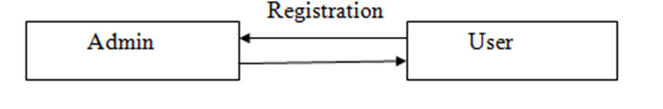

**Sharing Data:**

The canonical application is data sharing. The public auditing property is especially useful when we expect the delegation to be efficient and flexible. The schemes enable a content provider to share her data in a confidential and selective way, with a fixed and small cipher text expansion, by distributing to each authorized user a single and small aggregate key.

**Secure Cloud Storage:**

 Data robustness is a major requirement for storage systems. There have been many proposals of storing data over storage servers. One way to provide data robustness is to replicate a message such that each storage server stores a copy of the message. A decentralized erasure code is suitable for use in a distributed storage system.

**Proxy re-encryption:**

Proxy re-encryption schemes are crypto systems which allow third parties (proxies) to alter a cipher text which has been encrypted for one user, so that it may be decrypted by another user. By using proxy re-encryption technique the encrypted data (cipher text) in the cloud is again altered by the user. It provides highly secured information stored in the cloud. Every user will have a public key and private key. Public key of every user is known to everyone but private key is known only the particular user.

**Data retrieval:**

Reports and data are the two primary forms of the retrieved data from servers. There are some overlaps between them, but queries generally select a relatively small portion of the server, while reports show larger amounts of data. Queries also present the data in a standard format and usually display it on the monitor; whereas reports allow formatting of the output however you like and is normally retrieved.

**Data flow Diagram:**

A data flow diagram (DFD) is a graphical representation of the “flow” of data through an information system.

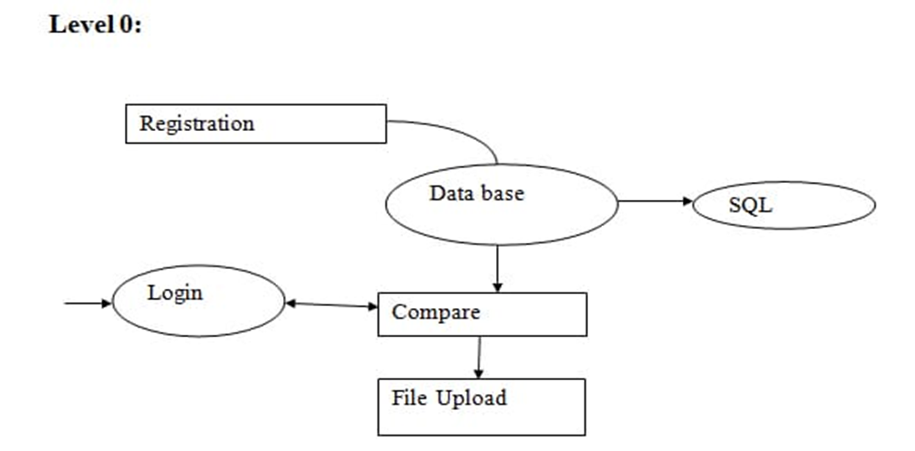

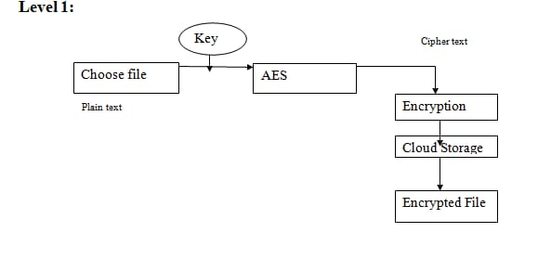

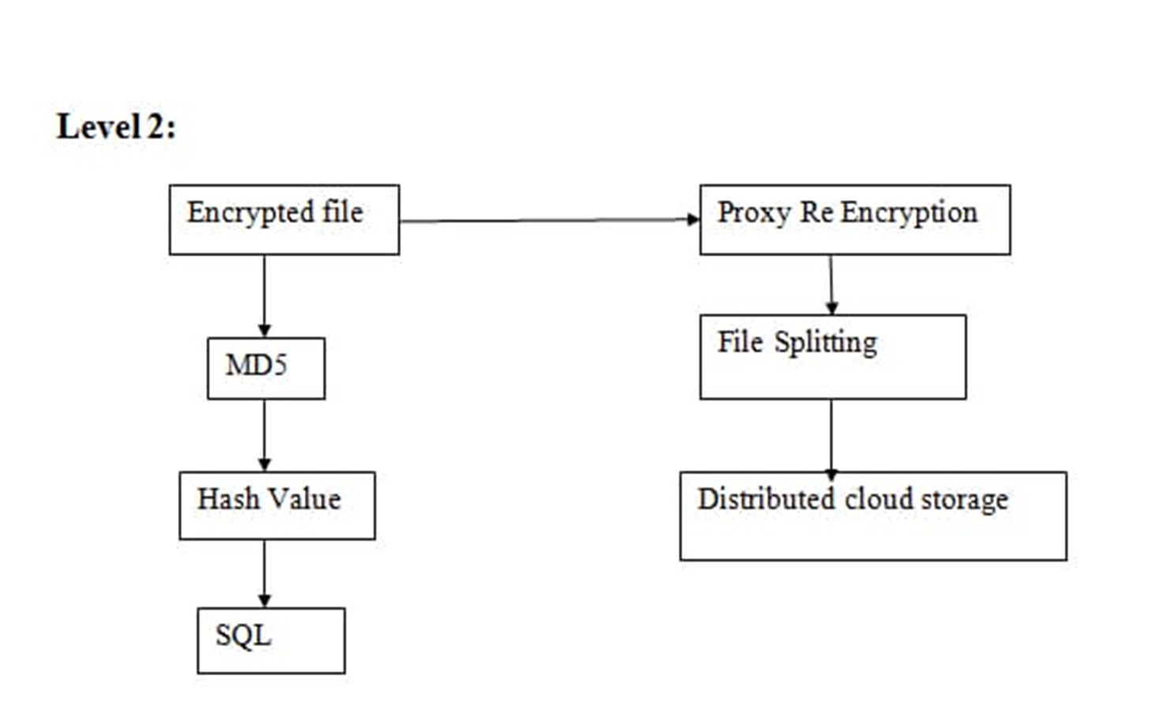

**4.3 UML Diagrams:**

**USE CASE DIAGRAM:-**

End user

Data encryption/encoding

Client

No of Server

Proxy Reencryption

Providekey

Server

Upload/Download

**Description:**

Use case diagrams gives a graphic overview of the actors involved in a system, different functions needed by those actors and how these different functions are interacted.

Here the sender and receiver are the actors and select video, select file, encryption key, decrypt data, extract data and view data are the functions.

**SEQUENCE DIAGRAM:-**

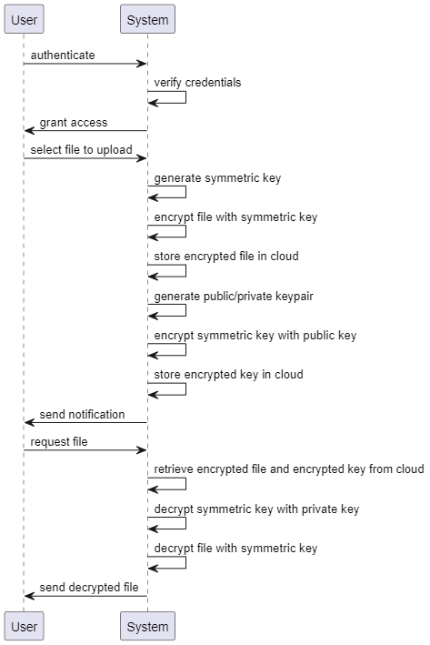

**Description**:

Sequence diagrams in UML shows how object interact with each other and the order those interactions occur. It’s important to note that they show the interactions for a particular scenario. The processes are represented vertically and interactions are show as arrows.

Here sender, receiver, embedding data and room are objects they interact each other. The arrow shows interaction like send cover video and data, reserving room etc.

**CLASS DIAGRAM:-**

**Description**:

It is the main building block of any object oriented solution. It shows the classes in a system, attributes and operations of each class and the relationship between each class.

A class has three parts, name at the top, attributes in the middle and operations or methods at the bottom. In large systems with many related classes, classes are grouped together to create class diagrams. Different relationships between classes are shown by different types of arrows.

Here sender, embed data, receiver, encrypt and decrypt are the classes, each class contains its own attribute and functions, they are related by arrows.

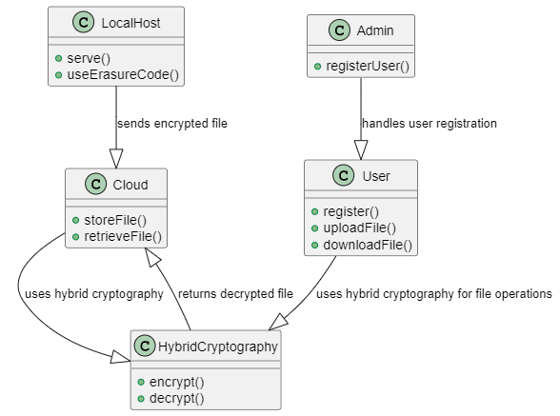

**COLLABORATION DIAGRAM:-**

**Description**:

collaboration diagram, is an interaction diagram that shows similar information to sequence diagrams but its primary focus is on object relationships.

On collaboration diagrams, objects are shown with association connectors between them. Messages are added to the associations and show as short arrows pointing in the direction of the message flow. The sequence of messages is shown through a numbering scheme

Here the objects like sender, receiver, room and Embed data are connected each other and messages are added to the associations.

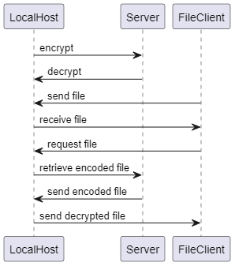

**ACTIVITY DIAGRAM:-**

**Description**:

Activity diagrams represent workflows in an graphical way. They can be used to describe business workflow or the operational workflow of any component in a system

* *rounded rectangles* represent *actions*;
* diamonds represent decisions;
* bars represent the start (split) or end (join) of concurrent activities;
* a black circle represents the start (initial state) of the workflow;
* an encircled black circle represents the end (final state).

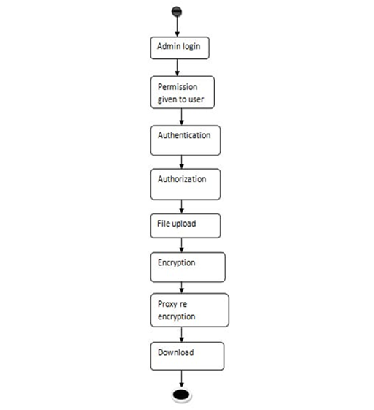

1. **System Implementation:**

**5.1 Algorithms**

**Advanced Encryption Standard (AES)**

**Definition**

The Advanced Encryption Standard (AES) is an [encryption](http://searchsecurity.techtarget.com/sDefinition/0,,sid14_gci212062,00.html) [algorithm](http://whatis.techtarget.com/definition/0,,sid9_gci211545,00.html) for securing sensitive but unclassified material by U.S. Government agencies and, as a likely consequence, may eventually become the de facto encryption standard for commercial transactions in the private sector. (Encryption for the US military and other classified communications is handled by separate, secret algorithms.)In January of 1997, a process was initiated by the National Institute of Standards and Technology ([NIST](http://searchsoftwarequality.techtarget.com/sDefinition/0,,sid92_gci212662,00.html)), a unit of the U.S. Commerce Department, to find a more robust replacement for the Data Encryption Standard ([DES](http://searchsecurity.techtarget.com/sDefinition/0,,sid14_gci213893,00.html)) and to a lesser degree Triple DES. The specification called for a symmetric algorithm (same [key](http://searchsecurity.techtarget.com/sDefinition/0,,sid14_gci213695,00.html) for encryption and decryption) using block encryption (see [block cipher](http://searchsecurity.techtarget.com/sDefinition/0,,sid14_gci213594,00.html)) of 128 bits in size, supporting key sizes of 128, 192 and 256 bits, as a minimum. The algorithm was required to be royalty-free for use worldwide and offer security of a sufficient level to protect data for the next 20 to 30 years. It was to be easy to implement in hardware and software, as well as in restricted environments (for example, in a [smart card](http://searchsecurity.techtarget.com/sDefinition/0,,sid14_gci213004,00.html)) and offer good defenses against various attack techniques.The entire selection process was fully open to public scrutiny and comment, it being decided that full visibility would ensure the best possible analysis of the designs. In 1998, the NIST selected 15 candidates for the AES, which were then subject to preliminary analysis by the world cryptographic community, including the National Security Agency. On the basis of this, in August 1999, NIST selected five algorithms for more extensive analysis. These were:

* MARS, submitted by a large team from IBM Research
* RC6, submitted by [RSA](http://searchsecurity.techtarget.com/sDefinition/0,,sid14_gci214273,00.html) Security
* [Rijndael](http://searchsecurity.techtarget.com/sDefinition/0,,sid14_gci523541,00.html), submitted by two Belgian cryptographers, Joan Daemen and Vincent Rijmen
* Serpent, submitted by Ross Andersen, Eli Biham and Lars Knudsen
* [Twofish](http://searchsecurity.techtarget.com/sDefinition/0,,sid14_gci763124,00.html), submitted by a large team of researchers including Counterpane's respected cryptographer, Bruce Schneier

Implementations of all of the above were tested extensively in [ANSI](http://searchdatacenter.techtarget.com/sDefinition/0,,sid80_gci213776,00.html) [C](http://searchwinit.techtarget.com/sDefinition/0,,sid1_gci211723,00.html) and [Java](http://searchsoa.techtarget.com/sDefinition/0,,sid26_gci212415,00.html) languages for speed and reliability in such measures as encryption and decryption speeds, key and algorithm set-up time and resistance to various attacks, both in hardware- and software-centric systems. Once again, detailed analysis was provided by the global cryptographic community (including some teams trying to break their own submissions). The end result was that on October 2, 2000, NIST announced that [Rijndael](http://searchsecurity.techtarget.com/sDefinition/0,,sid14_gci523541,00.html) had been selected as the proposed standard. On December 6, 2001, the Secretary of Commerce officially approved Federal Information Processing Standard ([FIPS](http://whatis.techtarget.com/definition/0,,sid9_gci213964,00.html)) 197, which specifies that all sensitive, unclassified documents will use Rijndael as the Advanced Encryption Standard.Also see [cryptography](http://searchsoftwarequality.techtarget.com/sDefinition/0,,sid92_gci214431,00.html), [data recovery agent (DRA)](http://searchsecuritychannel.techtarget.com/sDefinition/0,,sid97_gci1527174,00.html).

**RELATED GLOSSARY TERMS:** [RSA algorithm (Rivest-Shamir-Adleman)](http://searchsecurity.techtarget.com/definition/RSA), [data key](http://searchsecurity.techtarget.com/definition/data-key), [greynet (or graynet)](http://searchsecurity.techtarget.com/definition/greynet), [spam cocktail (or anti-spam cocktail)](http://searchsecurity.techtarget.com/definition/spam-cocktail), [fingerscanning (fingerprint scanning)](http://searchsecurity.techtarget.com/definition/fingerscanning),[munging](http://searchsecurity.techtarget.com/definition/munging), [insider threat](http://searchsecurity.techtarget.com/definition/insider-threat), [authentication server](http://searchsecurity.techtarget.com/definition/authentication-server), [defense in depth](http://searchsecurity.techtarget.com/definition/defense-in-depth), [nonrepudiation](http://searchsecurity.techtarget.com/definition/nonrepudiation).

**Explanations**

AES is based on a design principle known as a Substitution permutation network. It is fast in both software and hardware. Unlike its predecessor, DES, AES does not use a Feistel network.AES has a fixed block size of 128 bits and a key size of 128, 192, or 256 bits, whereas Rijndael can be specified with block and key sizes in any multiple of 32 bits, with a minimum of 128 bits. The blocksize has a maximum of 256 bits, but the keysize has no theoretical maximum.AES operates on a 4×4 column-major order matrix of bytes, termed the *state* (versions of Rijndael with a larger block size have additional columns in the state). Most AES calculations are done in a special finite field.The AES cipher is specified as a number of repetitions of transformation rounds that convert the input plaintext into the final output of ciphertext. Each round consists of several processing steps, including one that depends on the encryption key. A set of reverse rounds are applied to transform ciphertext back into the original plaintext using the same encryption key.

### High-level description of the algorithm

1. KeyExpansion—round keys are derived from the cipher key using Rijndael's key schedule
2. Initial Round
   1. AddRoundKey—each byte of the state is combined with the round key using bitwise xor
3. Rounds
   1. SubBytes—a non-linear substitution step where each byte is replaced with another according to lookup.
   2. ShiftRows—a transposition step where each row of the state is shifted cyclically a certain number of steps.
   3. MixColumns—a mixing operation which operates on the columns of the state, combining the four bytes in each column.
   4. AddRoundKey
4. Final Round (no MixColumns)
   1. SubBytes
   2. ShiftRows
   3. AddRoundKey

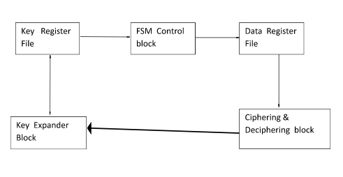

**Examples**

In this appendix, twenty examples are provided for the MAC generation process.  The underlying block cipher is either the AES algorithm or TDEA.  A block cipher key is fixed for each of the currently allowed key sizes, i.e., AES-128, AES-192, AES-256, two key TDEA, and three key TDEA. For each key, the generation of the associated subkeys is given, followed by four examples of MAC generation with the key.  The messages in each set of examples are derived by truncating a common fixed string of 64 bytes.  All strings are represented in hexadecimal notation, with a space (or a new line) inserted every 8 symbols, for readability.  As in the body of the Recommendation,  K1 and  K2denote the subkeys,  M denotes the message, and  T denotes the MAC.  For the AES algorithm examples, Tlen is 128, i.e., 32 hexadecimal symbols, and K denotes the key.  For the TDEA examples, Tlen is 64, i.e., 16 hexadecimal symbols, and the key, K, is the ordered triple of strings, (Key1, Key2, Key3).  For two key TDEA, Key1 = Key3. D.1  AES-128

For Examples 1–4 below, the block cipher is the AES algorithm with the following 128 bit key:

K    2b7e1516 28aed2a6 abf71588 09cf4f3c.

Subkey Generation

CIPHK(0

128

)    7df76b0c 1ab899b3 3e42f047 b91b546f

K1      fbeed618 35713366 7c85e08f 7236a8de

K2 f7ddac30 6ae266cc f90bc11e e46d513b

**Example Explanations:**

The Advanced Encryption Standard (AES) specifies  a FIPS-approved cryptographic algorithm that can be used to protect electronic data.  The AES algorithm is a symmetric block cipher that can encrypt (encipher) and decrypt (decipher) information. Encryption converts data to an unintelligible form called  ciphertext;  decrypting the  ciphertext converts the data back into its original form, called plaintext. The AES algorithm is capable of using cryptographic keys of 128, 192, and 256 bits to encrypt and decrypt data in blocks of 128 bits.

**MD5 Algorithm**

**Definition**

MD5 is an [algorithm](http://whatis.techtarget.com/definition/0,,sid9_gci211545,00.html) that is used to verify [data integrity](http://searchdatacenter.techtarget.com/sDefinition/0,,sid80_gci518970,00.html) through the creation of a 128-bit message digest from data input (which may be a message of any length) that is claimed to be as unique to that specific data as a fingerprint is to the specific individual. MD5, which was developed by Professor Ronald L. Rivest of MIT, is intended for use with [digital signature](http://searchsecurity.techtarget.com/sDefinition/0,,sid14_gci211953,00.html) applications, which require that  large files must be compressed by a secure method before being encrypted with a [secret key](http://searchsecurity.techtarget.com/sDefinition/0,,sid14_gci212830,00.html), under a [public key](http://searchsecurity.techtarget.com/sDefinition/0,,sid14_gci212845,00.html) cryptosystem. MD5 is currently a standard, Internet Engineering Task Force ([IETF](http://searchsoa.techtarget.com/sDefinition/0,,sid26_gci214017,00.html)) Request for Comments ([RFC](http://whatis.techtarget.com/definition/0,,sid9_gci214264,00.html)) 1321. According to the standard, it is "computationally infeasible" that any two messages that have been input to the MD5 algorithm could have as the output the same message digest, or that a false message could be created through apprehension of the message digest. MD5 is the third message digest algorithm created by Rivest. All three (the others are MD2 and MD4) have similar structures, but MD2 was optimized for 8-bit machines, in comparison with the two later formulas, which are optimized for 32-bit machines. The MD5 algorithm is an extension of MD4, which the critical review found to be fast, but possibly not absolutely secure. In comparison, MD5 is not quite as fast as the MD4 algorithm, but offers much more assurance of data security.

**Explanations**

The MD5 Message-Digest Algorithm is a widely used [cryptographic hash function](http://en.wikipedia.org/wiki/Cryptographic_hash_function) that produces a 128-[bit](http://en.wikipedia.org/wiki/Bit) (16-byte) hash value. Specified in [RFC 1321](http://tools.ietf.org/html/rfc1321), MD5 has been employed in a wide variety of security applications, and is also commonly used to check [data integrity](http://en.wikipedia.org/wiki/Data_integrity). However, it has been shown that MD5 is not [collision resistant](http://en.wikipedia.org/wiki/Collision_resistant); as such, MD5 is not suitable for applications like [SSL](http://en.wikipedia.org/wiki/Transport_Layer_Security) [certificates](http://en.wikipedia.org/wiki/Public_key_certificate) or [digital signatures](http://en.wikipedia.org/wiki/Digital_signature) that rely on this property. An MD5 hash is typically expressed as a 32-digit [hexadecimal](http://en.wikipedia.org/wiki/Hexadecimal) number.MD5 was designed by [Ron Rivest](http://en.wikipedia.org/wiki/Ron_Rivest) in 1991 to replace an earlier hash function, [MD4](http://en.wikipedia.org/wiki/MD4). In 1996, a flaw was found with the design of MD5. While it was not a clearly fatal weakness, cryptographers began recommending the use of other algorithms, such as [SHA-1](http://en.wikipedia.org/wiki/SHA-1) (which has since been found also to be vulnerable). In 2004, more serious flaws were discovered, making further use of the algorithm for security purposes questionable; specifically, a group of researchers described how to create a pair of files that share the same MD5 [checksum](http://en.wikipedia.org/wiki/Checksum). Further advances were made in breaking MD5 in 2005, 2006, and 2007. In an attack on MD5 published in December 2008, a group of researchers used this technique to fake SSL certificate validity.

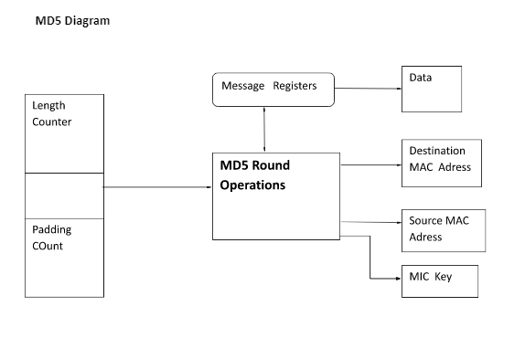

**Example**

MD5 (Message-Digest algorithm 5) is a widely used cryptographic hash function with a 128-bit hash value. Specified in RFC 1321, MD5 is one in a series of message digest algorithms designed by Professor Ronald Rivest of MIT (Rivest, 1994).   Today MD5 has been employed in a wide variety of security applications, and is also commonly used to check the integrity of files.MD5 is perfectly fine solution for security thinking, As one Java developer, we usually need to take over or coding to md5 encryption, the md5 encryption is very complicated and not to easy implement. Ideally, The standard edition of Java has really came with MD5 support built in. according by Java specification class MessageDigest support applications the functionality of a message digest algorithm, such as MD5 or SHA.. and it is defined in the java.security package. firstly you need some string manipulation to turn the plain text into byte array. This is going easy just use method getBytes() of class string. the digest is then updated from the bytes from the byte array and a hash computation is conducted upon them.

**import java.io.FileInputStream;**

**import java.io.UnsupportedEncodingException;**

**import java.math.BigInteger;**

**import java.security.MessageDigest;**

**import java.security.NoSuchAlgorithmException;**

**public class MD5 {**

**public static String getMD5(String input) {**

**try {**

**MessageDigest md = MessageDigest.getInstance("MD5");**

**byte[] messageDigest = md.digest(input.getBytes());**

**BigInteger number = new BigInteger(1, messageDigest);**

**String hashtext = number.toString(16);**

**// Now we need to zero pad it if you actually want the full 32 chars.**

**while (hashtext.length() < 32) {**

**hashtext = "0" + hashtext;**

**}**

**return hashtext;**

**}**

**catch (NoSuchAlgorithmException e) {**

**throw new RuntimeException(e);**

**}**

**}**

**public static void main(String[] args) throws NoSuchAlgorithmException {**

**System.out.println(getMD5("Javarmi.com"));**

**}**

**}**

**Example Explanations**

  It is simply a one-way fingerprint of the message. It doesn't include the original message, and you can't (generally) use the fingerprint (the md5sum) to 'figure out' the original message.Okay, so you take a message - like a password - and generate an MD5sum from it.. Can't you brute-force that? Like any password system, you could attempt to brute force the answer. However, MD5sum's are in a 128-bit space, meaning that to brute force it would take 2^128 attempts - thats over 3 with 38 zeroes afterit.Neat! Thats a lot. Are there any flaws in the algorithm that could speed it up?A birthday attack is based on the theory that there *might* be *one* md5sum that matches multiple inputs. In theory, it is possible that a "birthday" attack could be possible - two md5sum hashes could be the same. But even then, the total number of brute forces is at 2^64 attempts - still a heck of a lot.Okay. But couldn't (insert super-sneaky government agency here) build an md5 dictionary, and know what the password was with the md5?Yes. Its entirely possible. However - it would take some work to do so. For example, just for a dictionary consisting of Alphabet letters (upper and lower), and numbers, there would be 46,656,000,000 entries - all at 32 characters each. Thats over 1 terabyte of data to store and search! It could be done - absolutely. But is it likely? So its hard to brute force, what about dictionary attacks? Dictionary attacks are a way of attacking poor passwords - most people use words in their passwords. If you can guess the word - for example, "love", then you can cut down the number of tries it would take. Of course if you guess right, then your # of attacks = 1. However, in general, using common computers as of the writing of this (2005), you can generally get roughly 5 million attacks per second, or fast enough to guess all 8-character Alphanumericals within 497 days.

**Proxy re-encryption**

Proxy re-encryption (PRE) allows a proxy to convert a ciphertext encrypted under one key into an encryption of the same message under another key. The main idea is to place as little trust and reveal as little information to the proxy as necessary to allow it to perform its translations. At the very least, the proxy should not be able to learn the keys of the participants or the content of the messages it re-encrypts. However, in all prior PRE schemes, it is easy for the proxy to determine between which participants a re-encryption key can transform ciphertexts. This can be a problem in practice. For example, in a secure distributed file system, content owners may want to use the proxy to help re-encrypt sensitive information *without* revealing to the proxy the *identity* of the recipients.

In this work, we propose key-private (or anonymous) re-encryption keys as an additional useful property of PRE schemes. We formulate a definition of what it means for a PRE scheme to be secure and key-private. Surprisingly, we show that this property is not captured by prior definitions or achieved by prior schemes, including even the secure obfuscation of PRE by Hohenberger et al.  Finally, we propose the first key-private PRE construction and prove its CPA-security under a simple extension of Decisional Bilinear Diffie Hellman assumption and its key-privacy under the Decision Linear assumption in the standard model.

**Erasure code technique**

In [information theory](https://en.wikipedia.org/wiki/Information_theory), an erasure code is a [forward error correction](https://en.wikipedia.org/wiki/Forward_error_correction) (FEC) code for the [binary erasure channel](https://en.wikipedia.org/wiki/Binary_erasure_channel), which transforms a message of k symbols into a longer message (code word) with n symbols such that the original message can be recovered from a subset of the n symbols. The fraction r = k/n is called the [code rate](https://en.wikipedia.org/wiki/Code_rate), the fraction k’/k, where k’ denotes the number of symbols required for recovery, is called [reception efficiency](https://en.wikipedia.org/w/index.php?title=Reception_efficiency&action=edit&redlink=1).

**Optimal erasure codes**

Optimal erasure codes have the property that any k out of the n code word symbols are sufficient to recover the original message (i.e., they have optimal reception efficiency). Optimal erasure codes are [maximum distance separable codes](https://en.wikipedia.org/wiki/Maximum_distance_separable_code#MDS_codes) (MDS codes).Optimal codes are often costly (in terms of memory usage, CPU time, or both) when n is large. Except for very simple schemes, practical solutions usually have quadratic encoding and decoding [complexity](https://en.wikipedia.org/wiki/Computational_complexity_theory). In 2014, Lin et al. [[1]](https://en.wikipedia.org/wiki/Erasure_code#cite_note-1) gave an approach with operations.

**Examples**

In this appendix, twenty examples are provided for the MAC generation process.  The underlying block cipher is either the AES algorithm or TDEA.  A block cipher key is fixed for each of the currently allowed key sizes, i.e., AES-128, AES-192, AES-256, two key TDEA, and three key TDEA. For each key, the generation of the associated subkeys is given, followed by four examples of MAC generation with the key.  The messages in each set of examples are derived by truncating a common fixed string of 64 bytes.  All strings are represented in hexadecimal notation, with a space (or a new line) inserted every 8 symbols, for readability.  As in the body of the Recommendation,  K1 and  K2denote the subkeys,  M denotes the message, and  T denotes the MAC.  For the AES algorithm examples, Tlen is 128, i.e., 32 hexadecimal symbols, and K denotes the key.  For the TDEA examples, Tlen is 64, i.e., 16 hexadecimal symbols, and the key, K, is the ordered triple of strings, (Key1, Key2, Key3).  For two key TDEA, Key1 = Key3. D.1  AES-128

For Examples 1–4 below, the block cipher is the AES algorithm with the following 128 bit key:

K    2b7e1516 28aed2a6 abf71588 09cf4f3c.

Subkey Generation

CIPHK(0

128

)    7df76b0c 1ab899b3 3e42f047 b91b546f

K1      fbeed618 35713366 7c85e08f 7236a8de

K2 f7ddac30 6ae266cc f90bc11e e46d513b

**Example Explanations**

The Advanced Encryption Standard (AES) specifies a FIPS-approved cryptographic algorithm that can be used to protect electronic data.  The AES algorithm is a symmetric block cipher that can encrypt (encipher) and decrypt (decipher) information. Encryption converts data to an unintelligible form called cipher text; decrypting the cipher text converts the data back into its original form, called plaintext. The AES algorithm is capable of using cryptographic keys of 128, 192, and 256 bits to encrypt and decrypt data in blocks of 128 bits.

**TECHNOLOGIES AND PROTOTYPES**

**Java (programming language)**

### History

The JAVA language was created by James Gosling in June 1991 for use in a set top box project. The language was initially called Oak, after an oak tree that stood outside Gosling's office - and also went by the name Green - and ended up later being renamed to Java, from a list of random words. Gosling's goals were to implement a virtual machine and a language that had a familiar C/C++ style of notation. The first public implementation was Java 1.0 in 1995. It promised "Write Once, Run Anywhere” (WORA), providing no-cost runtimes on popular platforms. It was fairly secure and its security was configurable, allowing network and file access to be restricted. Major web browsers soon incorporated the ability to run secure Java applets within web pages. Java quickly became popular. With the advent of Java 2, new versions had multiple configurations built for different types of platforms. For example, J2EE was for enterprise applications and the greatly stripped down version J2ME was for mobile applications. J2SE was the designation for the Standard Edition. In 2006, for marketing purposes, new J2 versions were renamed Java EE, Java ME, and Java SE, respectively.

In 1997, Sun Microsystems approached the ISO/IEC JTC1 standards bodyand later the Ecma International to formalize Java, but it soon withdrew from the process. Java remains a standard that is controlled through the Java Community Process. At one time, Sun made most of its Java implementations available without charge although they were proprietary software. Sun's revenue from Java was generated by the selling of licenses for specialized products such as the Java Enterprise System. Sun distinguishes between its Software Development Kit (SDK) and Runtime Environment (JRE)which is a subset of the SDK, the primary distinction being that in the JRE, the compiler, utility programs, and many necessary header files are not present.

On 13 Novmber2006, Sun released much of Java as free softwareunder the terms of the GNU General Public License(GPL). On 8 May2007Sun finished the process, making all of Java's core code open source, aside from a small portion of code to which Sun did not hold the copyright.

### Primary goals

There were five primary goals in the creation of the Java language:

* It should use the object-oriented programming methodology.
* It should allow the same program to be executed on multiple operating systems.
* It should contain built-in support for using computer networks.
* It should be designed to execute code from remote sources securely.
* It should be easy to use by selecting what were considered the good parts of other object-oriented languages

### The Java Programming Language:

The Java programming language is a high-level language that can be characterized by all of the following buzzwords:

* Simple
* Architecture neutral
* Object oriented
* Portable
* Distributed
* High performance

|  |  |
| --- | --- |
|  |  |
|  |  |
|  |  |
|  |  |
|  |  |

Each of the preceding buzzwords is explained in [*The Java Language Environment*](http://java.sun.com/docs/white/langenv/) , a white paper written by James Gosling and Henry McGilton.

In the Java programming language, all source code is first written in plain text files ending with the .java extension. Those source files are then compiled into .class files by the javac compiler.

A .class file does not contain code that is native to your processor; it instead contains *byte codes* — the machine language of the Java Virtual Machine[1](http://java.sun.com/docs/books/tutorial/getStarted/intro/definition.html#FOOT#FOOT) (Java VM). The java launcher tool then runs your application with an instance of the Java Virtual Machine.

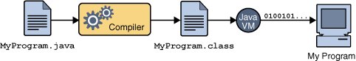

An overview of the software development process.

Because the Java VM is available on many different operating systems, the same .class files are capable of running on Microsoft Windows, the Solaris TM Operating System (Solaris OS), Linux, or Mac OS. Some virtual machines, such as the Java Hot Spot virtual machineperform additional steps at runtime to give your application a performance boost. This include various tasks such as finding performance bottlenecks and recompiling (to native code) frequently used sections of code.

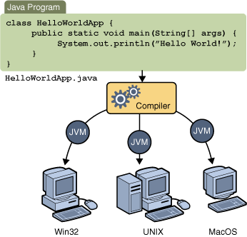

Through the Java VM, the same application is capable of running on multiple platforms.

### The Java Platform

A *platform* is the hardware or software environment in which a program runs. We've already mentioned some of the most popular platforms like Microsoft Windows, Linux, Solaris OS, and Mac OS. Most platforms can be described as a combination of the operating system and underlying hardware. The Java platform differs from most other platforms in that it's a software-only platform that runs on top of other hardware-based platforms.

**The Java platform has two components:**

The *Java Virtual Machine*

The *Java Application Programming Interface* (API)

You've already been introduced to the Java Virtual Machine; it's the base for the Java platform and is ported onto various hardware-based platforms.

The API is a large collection of ready-made software components that provide many useful capabilities. It is grouped into libraries of related classes and interfaces; these libraries are known as *packages*. The next section, What CanJavaTechnologyDo?Highlights some of the functionality provided by the API.

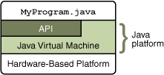

The API and Java Virtual Machine insulate the program from the underlying hardware.

As a platform-independent environment, the Java platform can be a bit slower than native code. However, advances in compiler and virtual machine technologies are bringing performance close to that of native code without threatening portability.

### Java Runtime Environment

The Java Runtime Environment, or JRE, is the software required to run any application deployed on the Java Platform. End-users commonly use a JRE in software packages and Web browser plug-in. Sun also distributes a superset of the JRE called the Java 2 SDK(more commonly known as the JDK), which includes development tools such as the Javacompiler,Javadoc, Jarand debugger.

One of the unique advantages of the concept of a runtime engine is that errors (exceptions) should not 'crash' the system. Moreover, in runtime engine environments such as Java there exist tools that attach to the runtime engine and every time that an exception of interest occurs they record debugging information that existed in memory at the time the exception was thrown (stack and heap values). These Automated Exception Handling tools provide 'root-cause' information for exceptions in Java programs that run in production, testing or development environments.

**Uses OF JAVA**

Blue is a smart card enabled with the secure, cross-platform, object-oriented Java Card API and technology. Blue contains an actual on-card processing chip, allowing for enhance able and multiple functionality within a single card. Applets that comply with the Java Card API specification can run on any third-party vendor card that provides the necessary Java Card Application Environment (JCAE). Not only can multiple applet programs run on a single card, but new applets and functionality can be added after the card is issued to the customer

* Java Can be used in Chemistry.
* In NASA also Java is used.
* In 2D and 3D applications java is used.
* In Graphics Programming also Java is used.
* In Animations Java is used.
* In Online and Web Applications Java is used.

**JSP :**

**JavaServer Pages** (**JSP**) is a Java technology that allows software developers to dynamically generate HTML, XML or other types of documents in response to a Web client request. The technology allows Java code and certain pre-defined actions to be embedded into static content.

The JSP syntax adds additional XML-like tags, called JSP actions, to be used to invoke built-in functionality. Additionally, the technology allows for the creation of JSP tag libraries that act as extensions to the standard HTML or XML tags. Tag libraries provide a platform independent way of extending the capabilities of a Web server.

JSPs are compiled into Java Servlet by a JSP compiler. A JSP compiler may generate a servlet in Java code that is then compiled by the Java compiler, or it may generate byte code for the servlet directly. JSPs can also be interpreted on-the-fly reducing the time taken to reload changes

JavaServer Pages (JSP) technology provides a simplified, fast way to create dynamic web content. JSP technology enables rapid development of web-based applications that are server and platform-independent.

**Architecture OF JSP**

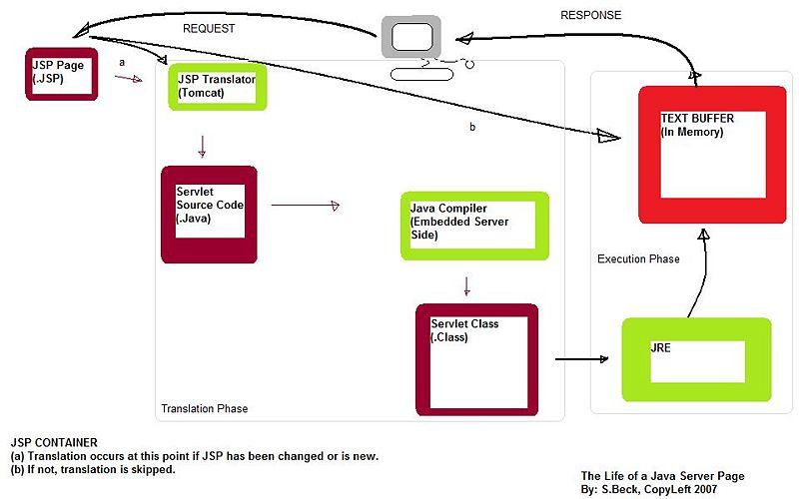

## The Advantages of JSP

Active Server Pages (ASP). ASP is a similar technology from Microsoft. The advantages of JSP are twofold. First, the dynamic part is written in Java, not Visual Basic or other MS-specific language, so it is more powerful and easier to use. Second, it is portable to other operating systems and non-Microsoft Web servers. Pure  Servlet. JSP doesn't give you anything that you couldn't in principle do with a Servlet. But it is more convenient to write (and to modify!) regular HTML than to have a zillion println statements that generate the HTML. Plus, by separating the look from the content you can put different people on different tasks: your Web page design experts can build the HTML, leaving places for your Servlet programmers to insert the dynamic content.

 Server-Side Includes (SSI). SSI is a widely-supported technology for including externally-defined pieces into a static Web page. JSP is better because it lets you use Servlet instead of a separate program to generate that dynamic part. Besides, SSI is really only intended for simple inclusions, not for "real" programs that use form data, make database connections, and the like.  JavaScript. JavaScript can generate HTML dynamically on the client. This is a useful capability, but only handles situations where the dynamic information is based on the client's environment.

With the exception of cookies, HTTP and form submission data is not available to JavaScript. And, since it runs on the client, JavaScript can't access server-side resources like databases, catalogs, pricing information, and the like. Static HTML. Regular HTML, of course, cannot contain dynamic information. JSP is so easy and convenient that it is quite feasible to augment HTML pages that only benefit marginally by the insertion of small amounts of dynamic data. Previously, the cost of using dynamic data would preclude its use in all but the most valuable instances.

**ARCHITECTURE OF JSP**

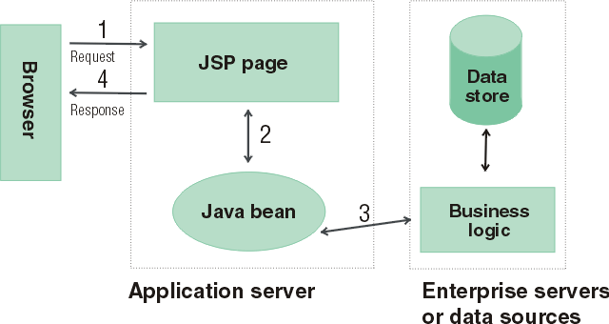

* The browser sends a request to a JSP page.
* The JSP page communicates with a Java bean.
* The Java bean is connected to a database.
* The JSP page responds to the browser.

**SERVLETS – FRONT END**

The Java Servlet API allows a software developer to add dynamic content to a Web server using the Java platform. The generated content is commonly HTML, but may be other data such as XML. Servlet are the Java counterpart to non-Java dynamic Web content technologies such as PHP, CGI and ASP.NET. Servlet can maintain state across many server transactions by using HTTP cookies, session variables or URL rewriting.

The Servlet API, contained in the Java package hierarchy javax. Servlet, defines the expected interactions of a Web container and a Servlet. A Web container is essentially the component of a Web server that interacts with the Servlet. The Web container is responsible for managing the lifecycle of Servlet, mapping a URL to a particular Servlet and ensuring that the URL requester has the correct access rights.

A Servlet is an object that receives a request and generates a response based on that request. The basic Servlet package defines Java objects to represent Servlet requests and responses, as well as objects to reflect the Servlet configuration parameters and execution environment. The package javax .Servlet. Http defines HTTP-specific subclasses of the generic Servlet elements, including session management objects that track multiple requests and responses between the Web server and a client. Servlet may be packaged in a WAR file as a Web application.

Servlet can be generated automatically by Java Server Pages(JSP), or alternately by template engines such as Web Macro. Often Servlet are used in conjunction with JSPs in a pattern called "Model 2”, which is a flavour of the model-view-controller pattern.

Servlet are Java technology's answer to CGI programming. They are programs that run on a Web server and build Web pages. Building Web pages on the fly is useful (and commonly done) for a number of reasons:.

The Web page is based on data submitted by the user. For example the results pages from search engines are generated this way, and programs that process orders for e-commerce sites do this as well. The data changes frequently. For example, a weather-report or news headlines page might build the page dynamically, perhaps returning a previously built page if it is still up to date. The Web page uses information from corporate databases or other such sources. For example, you would use this for making a Web page at an on-line store that lists current prices and number of items in stock.

### The Servlet Run-time Environment

A Servlet is a Java class and therefore needs to be executed in a Java VM by a service we call a Servlet engine. The Servlet engine loads the servlet class the first time the Servlet is requested, or optionally already when the Servlet engine is started. The Servlet then stays loaded to handle multiple requests until it is explicitly unloaded or the Servlet engine is shut down.

Some Web servers, such as Sun's Java Web Server (JWS), W3C's Jigsaw and Gefion Software's Lite Web Server (LWS) are implemented in Java and have a built-in Servlet engine. Other Web servers, such as Netscape's Enterprise Server, Microsoft's Internet Information Server (IIS) and the Apache Group's Apache, require a Servlet engine add-on module. The add-on intercepts all requests for Servlet, executes them and returns the response through the Web server to the client. Examples of Servlet engine add-ons are Gefion Software's WAI Cool Runner, IBM's Web Sphere, Live Software's JRun and New Atlanta's Servlet Exec.

All Servlet API classes and a simple Servlet-enabled Web server are combined into the Java Servlet Development Kit (JSDK), available for download at Sun's official Servlet site .To get started with Servlet I recommend that you download the JSDK and play around with the sample Servlet.

**Life Cycle OF Servlet**

* The Servlet lifecycle consists of the following steps:
* The Servlet class is loaded by the container during start-up.

The container calls the init() method. This method initializes the Servlet and must be called before the Servlet can service any requests. In the entire life of a Servlet, the init() method is called only once.  After initialization, the Servlet can service client-requests.

 Each request is serviced in its own separate thread. The container calls the service() method of the Servlet for every request.

The service() method determines the kind of request being made and dispatches it to an appropriate method to handle the request. The developer of the Servlet must provide an implementation for these methods. If a request for a method that is not implemented by the Servlet is made, the method of the parent class is called, typically resulting in an error being returned to the requester. Finally, the container calls the destroy() method which takes the Servlet out of service. The destroy() method like init() is called only once in the lifecycle of a Servlet.

### Request and Response Objects

The do Get method has two interesting parameters: HttpServletRequest and HttpServletResponse. These two objects give you full access to all information about the request and let you control the output sent to the client as the response to the request.  With CGI you read environment variables and stdin to get information about the request, but the names of the environment variables may vary between implementations and some are not provided by all Web servers.

The HttpServletRequest object provides the same information as the CGI environment variables, plus more, in a standardized way. It also provides methods for extracting HTTP parameters from the query string or the request body depending on the type of request (GET or POST). As a Servlet developer you access parameters the same way for both types of requests. Other methods give you access to all request headers and help you parse date and cookie headers.

Instead of writing the response to stdout as you do with CGI, you get an OutputStream or a PrintWriter from the HttpServletResponse. The OuputStream is intended for binary data, such as a GIF or JPEG image, and the PrintWriter for text output. You can also set all response headers and the status code, without having to rely on special Web server CGI configurations such as Non Parsed Headers (NPH). This makes your Servlet easier to install.

**ServletConfig and Servlet Context:**

There is only one Servlet Context in every application. This object can be used by all the Servlet to obtain application level information or container details. Every Servlet, on the other hand, gets its own ServletConfig object. This object provides initialization parameters for a servlet. A developer can obtain the reference to Servlet Context using either the ServletConfig object or Servlet Request object.

All servlets belong to one servlet context. In implementations of the 1.0 and 2.0 versions of the Servlet API all servlets on one host belongs to the same context, but with the 2.1 version of the API the context becomes more powerful and can be seen as the humble beginnings of an Application concept. Future versions of the API will make this even more pronounced.

Many servlet engines implementing the Servlet 2.1 API let you group a set of servlets into one context and support more than one context on the same host. The Servlet Context in the 2.1 API is responsible for the state of its servlets and knows about resources and attributes available to the servlets in the context. Here we will only look at how Servlet Context attributes can be used to share information among a group of servlets.

There are three Servlet Context methods dealing with context attributes: get Attribute, set Attribute and remove Attribute. In addition the servlet engine may provide ways to configure a servlet context with initial attribute values. This serves as a welcome addition to the servlet initialization arguments for configuration information used by a group of servlets, for instance the database identifier we talked about above, a style sheet URL for an application, the name of a mail server, etc.

**JDBC**

Java Database Connectivity (JDBC) is a programming framework for Java developers writing programs that access information stored in databases, spreadsheets, and flat files. JDBC is commonly used to connect a user program to a "behind the scenes" database, regardless of what database management software is used to control the database. In this way, JDBC is cross-platform. This article will provide an introduction and sample code that demonstrates database access from Java programs that use the classes of the JDBC API, which is available for free download from Sun's site.

A database that another program links to is called a data source. Many data sources, including products produced by Microsoft and Oracle, already use a standard called Open Database Connectivity (ODBC). Many legacy C and Perl programs use ODBC to connect to data sources. ODBC consolidated much of the commonality between database management systems. JDBC builds on this feature, and increases the level of abstraction. JDBC-ODBC bridges have been created to allow Java programs to connect to ODBC-enabled database software.

### JDBC Architecture

### Two-tier and Three-tier Processing Models

The JDBC API supports both two-tier and three-tier processing models for database access.

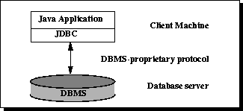

In the two-tier model, a Java applet or application talks directly to the data source. This requires a JDBC driver that can communicate with the particular data source being accessed. A user's commands are delivered to the database or other data source, and the results of those statements are sent back to the user. The data source may be located on another machine to which the user is connected via a network. This is referred to as a client/server configuration, with the user's machine as the client, and the machine housing the data source as the server. The network can be an intranet, which, for example, connects employees within a corporation, or it can be the Internet.

In the three-tier model, commands are sent to a "middle tier" of services, which then sends the commands to the data source. The data source processes the commands and sends the results back to the middle tier, which then sends them to the user.

 MIS directors find the three-tier model very attractive because the middle tier makes it possible to maintain control over access and the kinds of updates that can be made to corporate data. Another advantage is that it simplifies the deployment of applications. Finally, in many cases, the three-tier architecture can provide performance advantages.

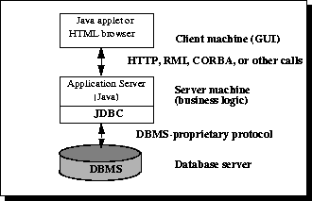

Until recently, the middle tier has often been written in languages such as C or C++, which offer fast performance. However, with the introduction of optimizing compilers that translate Java byte code into efficient machine-specific code and technologies such as Enterprise JavaBeans™, the Java platform is fast becoming the standard platform for middle-tier development. This is a big plus, making it possible to take advantage of Java's robustness, multithreading, and security features.

With enterprises increasingly using the Java programming language for writing server code, the JDBC API is being used more and more in the middle tier of a three-tier architecture. Some of the features that make JDBC a server technology are its support for connection pooling, distributed transactions, and disconnected rowsets. The JDBC API is also what allows access to a data source from a Java middle tier.

1. **Testing:**

**The various levels of testing are**

1. White Box Testing
2. Black Box Testing
3. Unit Testing
4. Functional Testing
5. Performance Testing
6. Integration Testing
7. Objective
8. Integration Testing
9. Validation Testing
10. System Testing
11. Structure Testing
12. Output Testing
13. User Acceptance Testing

**White Box Testing**

**White-box testing** (also known as **clear box testing**, **glass box testing**, **transparent box testing**, and **structural testing**) is a method of testing software that tests internal structures or workings of an application, as opposed to its functionality (i.e. black-box testing). In white-box testing an internal perspective of the system, as well as programming skills, are used to design test cases. The tester chooses inputs to exercise paths through the code and determine the appropriate outputs. This is analogous to testing nodes in a circuit, e.g. in-circuit testing (ICT).

While white-box testing can be applied at the unit, integration and system levels of the software testing process, it is usually done at the unit level. It can test paths within a unit, paths between units during integration, and between subsystems during a system–level test. Though this method of test design can uncover many errors or problems, it might not detect unimplemented parts of the specification or missing requirements.

White-box test design techniques include:

* Control flow testing
* Data flow testing
* Branch testing
* Path testing
* Statement coverage
* Decision coverage

White-box testing is a method of testing the application at the level of the source code. The test cases are derived through the use of the design techniques mentioned above: control flow testing, data flow testing, branch testing, path testing, statement coverage and decision coverage as well as modified condition/decision coverage. White-box testing is the use of these techniques as guidelines to create an error free environment by examining any fragile code.

These White-box testing techniques are the building blocks of white-box testing, whose essence is the careful testing of the application at the source code level to prevent any hidden errors later on. These different techniques exercise every visible path of the source code to minimize errors and create an error-free environment. The whole point of white-box testing is the ability to know which line of the code is being executed and being able to identify what the correct output should be.

**Levels**

1. Unit testing. White-box testing is done during unit testing to ensure that the code is working as intended, before any integration happens with previously tested code. White-box testing during unit testing catches any defects early on and aids in any defects that happen later on after the code is integrated with the rest of the application and therefore prevents any type of errors later on.
2. Integration testing. White-box testing at this level are written to test the interactions of each interface with each other. The Unit level testing made sure that each code was tested and working accordingly in an isolated environment and integration examines the correctness of the behaviour in an open environment through the use of white-box testing for any interactions of interfaces that are known to the programmer.
3. Regression testing. White-box testing during regression testing is the use of recycled white-box test cases at the unit and integration testing levels.

White-box testing's basic procedures involve the understanding of the source code that you are testing at a deep level to be able to test them. The programmer must have a deep understanding of the application to know what kinds of test cases to create so that every visible path is exercised for testing. Once the source code is understood then the source code can be analysed for test cases to be created. These are the three basic steps that white-box testing takes in order to create test cases:

1. Input, involves different types of requirements, functional specifications, detailed designing of documents, proper source code, security specifications. This is the preparation stage of white-box testing to layout all of the basic information.
2. Processing Unit, involves performing risk analysis to guide whole testing process, proper test plan, execute test cases and communicate results. This is the phase of building test cases to make sure they thoroughly test the application the given results are recorded accordingly.
3. Output, prepare final report that encompasses all of the above preparations and results.

**Black Box Testing**

**Black-box testing** is a method of software testing that examines the functionality of an application (e.g. what the software does) without peering into its internal structures or workings (see white-box testing). This method of test can be applied to virtually every level of software testing: unit, integration,system and acceptance. It typically comprises most if not all higher level testing, but can also dominate unit testing as well

**Test procedures**

Specific knowledge of the application's code/internal structure and programming knowledge in general is not required. The tester is aware of *what* the software is supposed to do but is not aware of *how* it does it. For instance, the tester is aware that a particular input returns a certain, invariable output but is not aware of *how* the software produces the output in the first place.

### Test cases

Test cases are built around specifications and requirements, i.e., what the application is supposed to do. Test cases are generally derived from external descriptions of the software, including specifications, requirements and design parameters. Although the tests used are primarily *functional* in nature, *non-functional* tests may also be used. The test designer selects both valid and invalid inputs and determines the correct output without any knowledge of the test object's internal structure.

### Test design techniques

Typical black-box test design techniques include:

* Decision table testing
* All-pairs testing
* State transition tables
* Equivalence partitioning
* Boundary value analysis

**Unit testing**

In computer programming, **unit testing** is a method by which individual units of source code, sets of one or more computer program modules together with associated control data, usage procedures, and operating procedures are tested to determine if they are fit for use. Intuitively, one can view a unit as the smallest testable part of an application. In procedural programming, a unit could be an entire module, but is more commonly an individual function or procedure. In object-oriented programming, a unit is often an entire interface, such as a class, but could be an individual method. Unit tests are created by programmers or occasionally by white box testers during the development process.

Ideally, each test case is independent from the others. Substitutes such as method stubs, mock objects, fakes, and test harnesses can be used to assist testing a module in isolation. Unit tests are typically written and run by software developers to ensure that code meets its design and behaves as intended. Its implementation can vary from being very manual (pencil and paper)to being formalized as part of build automation.

Testing will not catch every error in the program, since it cannot evaluate every execution path in any but the most trivial programs. The same is true for unit testing. Additionally, unit testing by definition only tests the functionality of the units themselves. Therefore, it will not catch integration errors or broader system-level errors (such as functions performed across multiple units, or non-functional test areas such as performance).

Unit testing should be done in conjunction with other software testing activities, as they can only show the presence or absence of particular errors; they cannot prove a complete absence of errors. In order to guarantee correct behaviour for every execution path and every possible input, and ensure the absence of errors, other techniques are required, namely the application of formal methods to proving that a software component has no unexpected behaviour.

Software testing is a combinatorial problem. For example, every Boolean decision statement requires at least two tests: one with an outcome of "true" and one with an outcome of "false". As a result, for every line of code written, programmers often need 3 to 5 lines of test code.

 This obviously takes time and its investment may not be worth the effort. There are also many problems that cannot easily be tested at all – for example those that are nondeterministic or involve multiple threads. In addition, code for a unit test is likely to be at least as buggy as the code it is testing. Fred Brooks in The Mythical Man-Month quotes: *never take two chronometers to sea. Always take one or three.* Meaning, if two chronometers contradict, how do you know which one is correct?

Another challenge related to writing the unit tests is the difficulty of setting up realistic and useful tests. It is necessary to create relevant initial conditions so the part of the application being tested behaves like part of the complete system. If these initial conditions are not set correctly, the test will not be exercising the code in a realistic context, which diminishes the value and accuracy of unit test results.

To obtain the intended benefits from unit testing, rigorous discipline is needed throughout the software development process. It is essential to keep careful records not only of the tests that have been performed, but also of all changes that have been made to the source code of this or any other unit in the software. Use of a version control system is essential. If a later version of the unit fails a particular test that it had previously passed, the version-control software can provide a list of the source code changes (if any) that have been applied to the unit since that time.

It is also essential to implement a sustainable process for ensuring that test case failures are reviewed daily and addressed immediately if such a process is not implemented and ingrained into the team's workflow, the application will evolve out of sync with the unit test suite, increasing false positives and reducing the effectiveness of the test suite.

Unit testing embedded system software presents a unique challenge: Since the software is being developed on a different platform than the one it will eventually run on, you cannot readily run a test program in the actual deployment environment, as is possible with desktop programs.[[7]](http://en.wikipedia.org/wiki/Unit_testing#cite_note-7)

**Functional testing**

**Functional testing** is a quality assurance (QA) process and a type of black box testing that bases its test cases on the specifications of the software component under test. Functions are tested by feeding them input and examining the output, and internal program structure is rarely considered (not like in white-box testing). Functional Testing usually describes *what* the system does.

Functional testing differs from system testing in that functional testing "*verifies* a program by checking it against ... design document(s) or specification(s)", while system testing "*validate* a program by checking it against the published user or system requirements" (Kane, Falk, Nguyen 1999, p. 52).

Functional testing typically involves five steps .The identification of functions that the software is expected to perform

1. The creation of input data based on the function's specifications
2. The determination of output based on the function's specifications
3. The execution of the test case
4. The comparison of actual and expected outputs

**Performance testing**

In software engineering, **performance testing** is in general testing performed to determine how a system performs in terms of responsiveness and stability under a particular workload. It can also serve to investigate, measure, validate or verify other quality attributes of the system, such as scalability, reliability and resource usage.

Performance testing is a subset of performance engineering, an emerging computer science practice which strives to build performance into the implementation, design and architecture of a system.

**Testing types**

### Load testing:

Load testing is the simplest form of performance testing. A load test is usually conducted to understand the behaviour of the system under a specific expected load. This load can be the expected concurrent number of users on the application performing a specific number of transactions within the set duration. This test will give out the response times of all the important business critical transactions. If the database, application server, etc. are also monitored, then this simple test can itself point towards bottlenecks in the application software.

### Stress testing:

Stress testing is normally used to understand the upper limits of capacity within the system. This kind of test is done to determine the system's robustness in terms of extreme load and helps application administrators to determine if the system will perform sufficiently if the current load goes well above the expected maximum.

### Soak testing:

Soak testing, also known as endurance testing, is usually done to determine if the system can sustain the continuous expected load. During soak tests, memory utilization is monitored to detect potential leaks. Also important, but often overlooked is performance degradation. That is, to ensure that the throughput and/or response times after some long period of sustained activity are as good as or better than at the beginning of the test. It essentially involves applying a significant load to a system for an extended, significant period of time. The goal is to discover how the system behaves under sustained use.

### Spike testing:

Spike testing is done by suddenly increasing the number of or load generated by, users by a very large amount and observing the behaviour of the system. The goal is to determine whether performance will suffer, the system will fail, or it will be able to handle dramatic changes in load.

### Configuration testing:

Rather than testing for performance from the perspective of load, tests are created to determine the effects of configuration changes to the system's components on the system's performance and behaviour. A common example would be experimenting with different methods of load-balancing.

**Isolation testing**

Isolation testing is not unique to performance testing but involves repeating a test execution that resulted in a system problem. Often used to isolate and confirm the fault domain.

**Integration testing**

**Integration testing** (sometimes called **integration and testing**, abbreviated **I&T**) is the phase in software testing in which individual software modules are combined and tested as a group. It occurs after unit testing and before validation testing. Integration testing takes as its input modules that have been unit tested, groups them in larger aggregates, applies tests defined in an integration test plan to those aggregates, and delivers as its output the integrated system ready for system testing.

**Purpose**

The purpose of integration testing is to verify functional, performance, and reliability requirements placed on major design items. These "design items", i.e. assemblages (or groups of units), are exercised through their interfaces using black box testing, success and error cases being simulated via appropriate parameter and data inputs. Simulated usage of shared data areas and inter-process communication is tested and individual subsystems are exercised through their input interface.

Test cases are constructed to test whether all the components within assemblages interact correctly, for example across procedure calls or process activations, and this is done after testing individual modules, i.e. unit testing. The overall idea is a "building block" approach, in which verified assemblages are added to a verified base which is then used to support the integration testing of further assemblages.

Some different types of integration testing are big bang, top-down, and bottom-up. Other Integration Patterns are: Collaboration Integration, Backbone Integration, Layer Integration, Client/Server Integration, Distributed Services Integration and High-frequency Integration.

### Big Bang

In this approach, all or most of the developed modules are coupled together to form a complete software system or major part of the system and then used for integration testing. The Big Bang method is very effective for saving time in the integration testing process. However, if the test cases and their results are not recorded properly, the entire integration process will be more complicated and may prevent the testing team from achieving the goal of integration testing.

A type of Big Bang Integration testing is called **Usage Model testing**. Usage Model Testing can be used in both software and hardware integration testing. The basis behind this type of integration testing is to run user-like workloads in integrated user-like environments. In doing the testing in this manner, the environment is proofed, while the individual components are proofed indirectly through their use.

Usage Model testing takes an optimistic approach to testing, because it expects to have few problems with the individual components. The strategy relies heavily on the component developers to do the isolated unit testing for their product. The goal of the strategy is to avoid redoing the testing done by the developers, and instead flesh-out problems caused by the interaction of the components in the environment.

For integration testing, Usage Model testing can be more efficient and provides better test coverage than traditional focused functional integration testing. To be more efficient and accurate, care must be used in defining the user-like workloads for creating realistic scenarios in exercising the environment. This gives confidence that the integrated environment will work as expected for the target customers.

### Top-down and Bottom-up

**Bottom Up Testing** is an approach to integrated testing where the lowest level components are tested first, then used to facilitate the testing of higher level components. The process is repeated until the component at the top of the hierarchy is tested.

All the bottom or low-level modules, procedures or functions are integrated and then tested. After the integration testing of lower level integrated modules, the next level of modules will be formed and can be used for integration testing. This approach is helpful only when all or most of the modules of the same development level are ready. This method also helps to determine the levels of software developed and makes it easier to report testing progress in the form of a percentage.

**Top Down Testing** is an approach to integrated testing where the top integrated modules are tested and the branch of the module is tested step by step until the end of the related module.

**Sandwich Testing** is an approach to combine top down testing with bottom up testing.

The main advantage of the Bottom-Up approach is that bugs are more easily found. With Top-Down, it is easier to find a missing branch link

**Verification and validation**

**Verification and Validation** are independent procedures that are used together for checking that a product, service, or system meets requirements and specifications and that it full fills its intended purpose.  These are critical components of a quality management system such as ISO 9000. The words "verification" and "validation" are sometimes preceded with "Independent" (or IV&V), indicating that the verification and validation is to be performed by a disinterested third party.

It is sometimes said that validation can be expressed by the query "Are you building the right thing?" and verification by "Are you building it right?"In practice, the usage of these terms varies. Sometimes they are even used interchangeably.

The PMBOK guide, an IEEE standard, defines them as follows in its 4th edition

* "**Validation.** The assurance that a product, service, or system meets the needs of the customer and other identified stakeholders. It often involves acceptance and suitability with external customers. Contrast with *verification*."
* "**Verification**. The evaluation of whether or not a product, service, or system complies with a regulation, requirement, specification, or imposed condition. It is often an internal process. Contrast with *validation*."
* Verification is intended to check that a product, service, or system (or portion thereof, or set thereof) meets a set of initial design specifications. In the development phase, verification procedures involve performing special tests to model or simulate a portion, or the entirety, of a product, service or system, then performing a review or analysis of the modelling results. In the post-development phase, verification procedures involve regularly repeating tests devised specifically to ensure that the product, service, or system continues to meet the initial design requirements, specifications, and regulations as time progresses. It is a process that is used to evaluate whether a product, service, or system complies with regulations, specifications, or conditions imposed at the start of a development phase. Verification can be in development, scale-up, or production. This is often an internal process.
* Validation is intended to check that development and verification procedures for a product, service, or system (or portion thereof, or set thereof) result in a product, service, or system (or portion thereof, or set thereof) that meets initial requirements. For a new development flow or verification flow, validation procedures may involve modelling either flow and using simulations to predict faults or gaps that might lead to invalid or incomplete verification or development of a product, service, or system (or portion thereof, or set thereof). A set of validation requirements, specifications, and regulations may then be used as a basis for qualifying a development flow or verification flow for a product, service, or system (or portion thereof, or set thereof). Additional validation procedures also include those that are designed specifically to ensure that modifications made to an existing qualified development flow or verification flow will have the effect of producing a product, service, or system (or portion thereof, or set thereof) that meets the initial design requirements, specifications, and regulations; these validations help to keep the flow qualified. It is a process of establishing evidence that provides a high degree of assurance that a product, service, or system accomplishes its intended requirements. This often involves acceptance of fitness for purpose with end users and other product stakeholders. This is often an external process.
* It is sometimes said that validation can be expressed by the query "Are you building the right thing?" and verification by "Are you building it right?". "Building the right thing" refers back to the user's needs, while "building it right" checks that the specifications are correctly implemented by the system. In some contexts, it is required to have written requirements for both as well as formal procedures or protocols for determining compliance.
* It is entirely possible that a product passes when verified but fails when validated. This can happen when, say, a product is built as per the specifications but the specifications themselves fail to address the user’s needs.

**Activities**

Verification of machinery and equipment usually consists of design qualification (DQ), installation qualification (IQ), operational qualification (OQ), and performance qualification (PQ). DQ is usually a vendor's job. However, DQ can also be performed by the user, by confirming through review and testing that the equipment meets the written acquisition specification. If the relevant document or manuals of machinery/equipment are provided by vendors, the later 3Q needs to be thoroughly performed by the users who work in an industrial regulatory environment. Otherwise, the process of IQ, OQ and PQ is the task of validation. The typical example of such a case could be the loss or absence of vendor's documentation for legacy equipment or do-it-yourself (DIY) assemblies (e.g., cars, computers etc.) and, therefore, users should endeavour to acquire DQ document beforehand. Each template of DQ, IQ, OQ and PQ usually can be found on the internet respectively, whereas the DIY qualifications of machinery/equipment can be assisted either by the vendor's training course materials and tutorials, or by the published guidance books, such as *step-by-step* series if the acquisition of machinery/equipment is not bundled with on- site qualification services. This kind of the DIY approach is also applicable to the qualifications of software, computer operating systems and a manufacturing process. The most important and critical task as the last step of the activity is to generating and archiving machinery/equipment qualification reports for auditing purposes, if regulatory compliances are mandatory.

Qualification of machinery/equipment is venue dependent, in particular items that are shock sensitive and require balancing or calibration, and re-qualification needs to be conducted once the objects are relocated. The full scales of some equipment qualifications are even time dependent as consumables are used up (i.e. filters) or springs stretch out, requiring recalibration, and hence re-certification is necessary when a specified due time lapse Re-qualification of machinery/equipment should also be conducted when replacement of parts, or coupling with another device, or installing a new application software and restructuring of the computer which affects especially the pre-settings, such as on BIOS, registry, disk drive partition table, dynamically-linked (shared) libraries, or an ini file etc., have been necessary. In such a situation, the specifications of the parts/devices/software and restructuring proposals should be appended to the qualification document whether the parts/devices/software are genuine or not.

Torres and Hyman have discussed the suitability of non-genuine parts for clinical use and provided guidelines for equipment users to select appropriate substitutes which are capable to avoid adverse effects. In the case when genuine parts/devices/software are demanded by some of regulatory requirements, then re-qualification does not need to be conducted on the non-genuine assemblies. Instead, the asset has to be recycled for non-regulatory purposes.

When machinery/equipment qualification is conducted by a standard endorsed third party such as by an ISO standard accredited company for a particular division, the process is called certification. Currently, the coverage of ISO/IEC 15408 certification by an ISO/IEC 27001 accredited organization is limited; the scheme requires a fair amount of efforts to get popularized.

**System testing**

**System testing** of software or hardware is testing conducted on a complete, integrated system to evaluate the system's compliance with its specified requirements. System testing falls within the scope of black box testing, and as such, should require no knowledge of the inner design of the code or logic.

As a rule, system testing takes, as its input, all of the "integrated" software components that have passed integration testing and also the software system itself integrated with any applicable hardware system(s). The purpose of integration testing is to detect any inconsistencies between the software units that are integrated together (called *assemblages*) or between any of the *assemblages* and the hardware. System testing is a more limited type of testing; it seeks to detect defects both within the "inter-assemblages" and also within the system as a whole.

System testing is performed on the entire system in the context of a Functional Requirement Specification(s) (FRS) and/or a System Requirement Specification (SRS). System testing tests not only the design, but also the behavior and even the believed expectations of the customer. It is also intended to test up to and beyond the bounds defined in the software/hardware requirements specification

**Types of tests to include in system testing**

The following examples are different types of testing that should be considered during System testing:

* Graphical user interface testing
* Usability testing
* Software performance testing
* Compatibility testing
* Exception handling
* Load testing
* Volume testing
* Stress testing
* Security testing
* Scalability testing
* Sanity testing
* Smoke testing
* Exploratory testing
* Ad hoc testing
* Regression testing
* Installation testing
* Maintenance testing Recovery testing and failover testing.
* Accessibility testing, including compliance with:
  + Americans with Disabilities Act of 1990
  + Section 508 Amendment to the Rehabilitation Act of 1973
  + Web Accessibility Initiative (WAI) of the World Wide Web Consortium (W3C)

Although different testing organizations may prescribe different tests as part of System testing, this list serves as a general framework or foundation to begin with.

**Structure Testing:**

It is concerned with exercising the internal logic of a program and traversing particular execution paths.

**Output Testing:**

* Output of test cases compared with the expected results created during design of test cases.
* Asking the user about the format required by them tests the output generated or displayed by the system under consideration.
* Here, the output format is considered into two was, one is on screen and another one is printed format.
* The output on the screen is found to be correct as the format was designed in the system design phase according to user needs.
* The output comes out as the specified requirements as the user’s hard copy.

**User acceptance Testing:**

* Final Stage, before handling over to the customer which is usually carried out by the customer where the test cases are executed with actual data.
* The system under consideration is tested for user acceptance and constantly keeping touch with the prospective system user at the time of developing and making changes whenever required.
* It involves planning and execution of various types of test in order to demonstrate that the implemented software system satisfies the requirements stated in the requirement document.

**Two set of acceptance test to be run:**

1. Those developed by quality assurance group.
2. Those developed by customer.
3. **Results :**

**Coding:**

**Database**

/*

SQLyog - Free MySQL GUI v5.13

Host - 5.0.22-community-nt : Database - erasurecode

*********************************************************************

Server version : 5.0.22-community-nt

*/  
SET NAMES utf8;

SET SQL_MODE='';

create database if not exists `erasurecode`;

USE `erasurecode`;

SET@OLD_SQL_MODE=@@SQL_MODE, SQL_MODE='NO_AUTO_VALUE_ON_ZERO';

 /*Table structure for table `admin` */

DROP TABLE IF EXISTS `admin`;

CREATE TABLE `admin` (

  `username` varchar(30) default NULL,

  `password` varchar(30) default NULL

) ENGINE=InnoDB DEFAULT CHARSET=latin1;

/*Data for the table `admin` */

insert into `admin` (`username`,`password`) values ('deva','deva');

/*Table structure for table `gender` */

DROP TABLE IF EXISTS `gender`;

CREATE TABLE `gender` (

  `Gender` varchar(20) default NULL

) ENGINE=InnoDB DEFAULT CHARSET=latin1;

/*Data for the table `gender` */

insert into `gender` (`Gender`) values ('Male');

insert into `gender` (`Gender`) values ('Female');

/*Table structure for table `ownerprofile` */

DROP TABLE IF EXISTS `ownerprofile`;

CREATE TABLE `ownerprofile` (

  `UserName` varchar(35) default NULL,

  `groupname` varchar(35) default NULL,

  `filename` varchar(700) NOT NULL,

  `server1` varchar(100) default NULL,

  `server2` varchar(100) default NULL,

  `server3` varchar(100) default NULL,

  `server4` varchar(100) default NULL,

  PRIMARY KEY  (`filename`)

) ENGINE=InnoDB DEFAULT CHARSET=latin1;

/*Data for the table `ownerprofile` */

Insert into `ownerprofile` (`UserName`,`groupname`,`filename`,`server1`,`server2`,`server3`,`server4`) values ('ram','ram','3.jpg','ef3cad6eee251f670014365fde992889e73f1a8e','ef3cad6eee251f670014365fde992889e73f1a8ekey1','ef3cad6eee251f670014365fde992889e73f1a8ekey2','ef3cad6eee251f670014365fde992889e73f1a8ekey3');

/*Table structure for table `registration` */

DROP TABLE IF EXISTS `registration`;

CREATE TABLE `registration` (

  `username` varchar(30) default NULL,

  `password` varchar(30) default NULL,

  `gender` varchar(20) default NULL,

  `email` varchar(50) default NULL,

  `phoneno` varchar(50) default NULL,

  `userproductkey` varchar(50) default NULL

) ENGINE=InnoDB DEFAULT CHARSET=latin1;

/*Data for the table `registration` */

insert into `registration` (`username`,`password`,`gender`,`email`,`phoneno`,`userproductkey`) values ('ram','ram','male','deva@gamil.com','1234','asdfasdfasdfasdf');

insert into `registration` (`username`,`password`,`gender`,`email`,`phoneno`,`userproductkey`) values ('deva ',NULL,NULL,NULL,NULL,NULL);

insert into `registration` (`username`,`password`,`gender`,`email`,`phoneno`,`userproductkey`) values ('kumar',NULL,NULL,NULL,NULL,NULL);

SET SQL_MODE=@OLD_SQL_MODE;

**Admin Servlet Code:**

*/

package com.ErasureCode;

import java.io.IOException;

import java.io.PrintWriter;

import java.sql.Connection;

import java.sql.DriverManager;

import java.sql.ResultSet;

import java.sql.Statement;

import javax.servlet.ServletException;

import javax.servlet.http.HttpServlet;

import javax.servlet.http.HttpServletRequest;

import javax.servlet.http.HttpServletResponse;

import javax.servlet.http.HttpSession;

import java.io.*;

import javax.servlet.*;

import javax.servlet.http.*;

/**

*

* @author Admin

*/

public class AdminServlet extends HttpServlet {

private Object out;

/**

* Processes requests for both HTTP <code>GET</code> and <code>POST</code>

* methods.

*

* @param request servlet request

* @param response servlet response

* @throws ServletException if a servlet-specific error occurs

* @throws IOException if an I/O error occurs

*/

protected void processRequest(HttpServletRequest request, HttpServletResponse response)

throws ServletException, IOException {

response.setContentType("text/html;charset=UTF-8");

try (PrintWriter out = response.getWriter()) {

/* TODO output your page here. You may use following sample code. */

out.println("<!DOCTYPE html>");

out.println("<html>");

out.println("<head>");

out.println("<title>Servlet AdminServlet</title>");

out.println("</head>");

out.println("<body>");

out.println("<h1>Servlet AdminServlet at " + request.getContextPath() + "</h1>");

out.println("</body>");

out.println("</html>");

}

}

// <editor-fold defaultstate="collapsed" desc="HttpServlet methods. Click on the + sign on the left to edit the code.">

/**

* Handles the HTTP <code>GET</code> method.

*

* @param request servlet request

* @param response servlet response

* @throws ServletException if a servlet-specific error occurs

* @throws IOException if an I/O error occurs

*/

@Override

protected void doGet(HttpServletRequest request, HttpServletResponse response)

throws ServletException, IOException {

processRequest(request, response);

}

/**

* Handles the HTTP <code>POST</code> method.

*

* @param request servlet request

* @param response servlet response

* @throws ServletException if a servlet-specific error occurs

* @throws IOException if an I/O error occurs

*/

@Override

protected void doPost(HttpServletRequest request, HttpServletResponse response)

throws ServletException, IOException {

HttpSession session1=request.getSession();

Connection con=null;

Statement st=null;

ResultSet rs=null;

try(PrintWriter out = response.getWriter())

{

String Username=request.getParameter("username");

String Password=request.getParameter("password");

System.out.println("this line my cheking======="+Username);

System.out.println("this line my cheking======="+Password);

Class.forName("com.mysql.jdbc.Driver");

con=DriverManager.getConnection("jdbc:mysql://localhost:3306/imageselectionerasurecode","root","password");

st=con.createStatement();

rs=st.executeQuery("select * from admin where username='"+Username+"' and password='"+Password+"'");

if(rs.next())

{

response.sendRedirect("UserReg.jsp");

}

else

{

//  out.print("Sorry UserName or Password Error!");

RequestDispatcher rd=request.getRequestDispatcher("Admin1.jsp");

rd.include(request, response);

out.print("<br><br><br><h1><center>Sorry UserName or Password Error!"+"</h1>");

}

}

catch(Exception ex)

{

ex.printStackTrace();

}

}

**Results Screenshots:**

**SCREENSHOTS:**

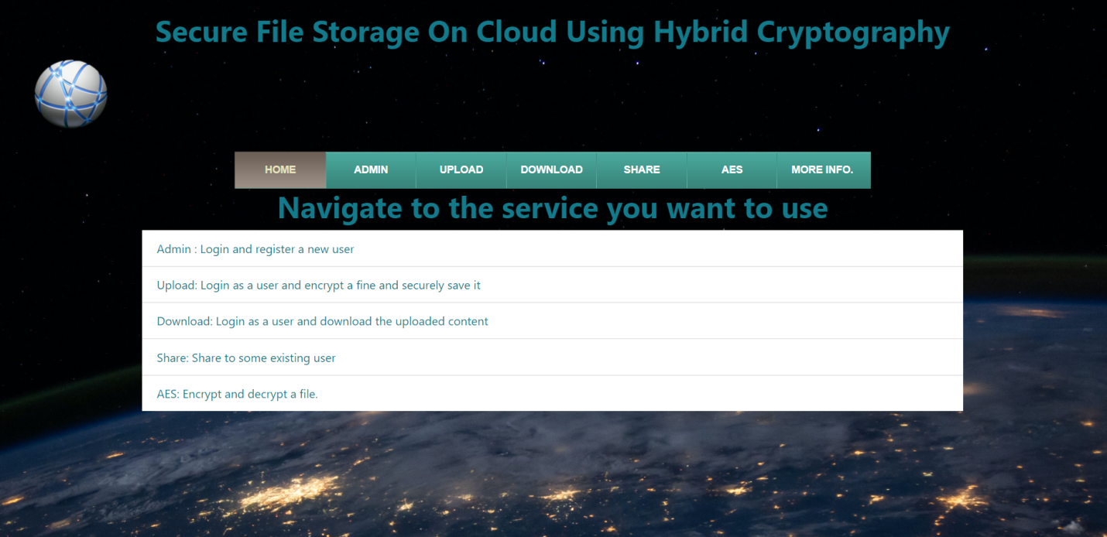

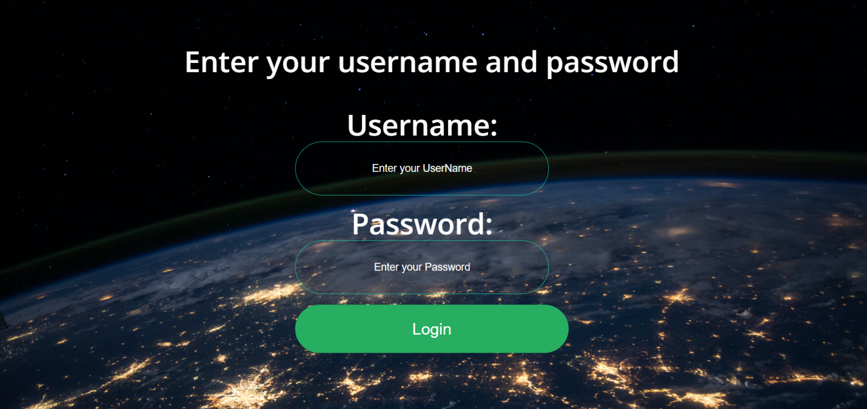

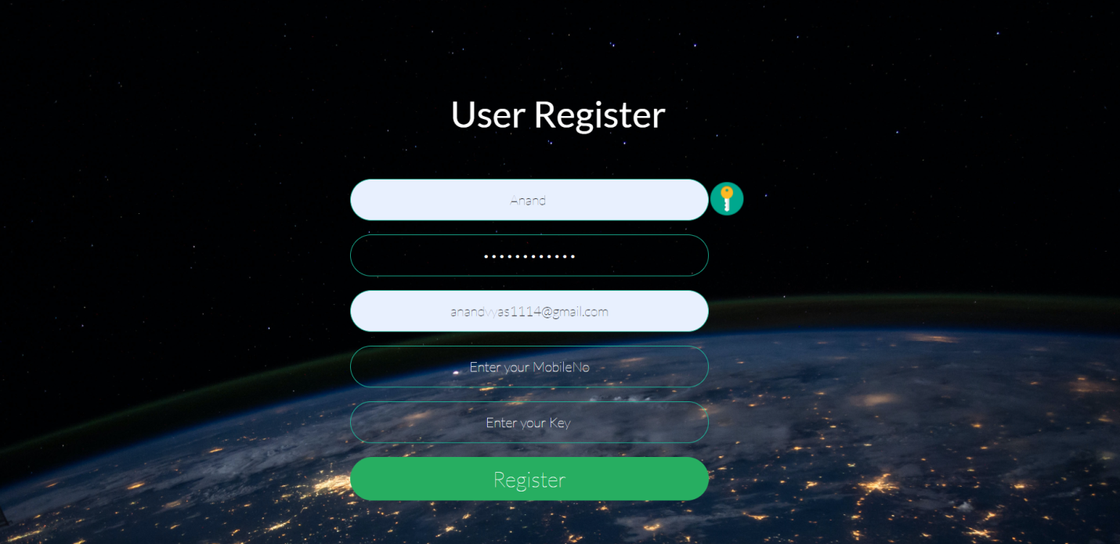



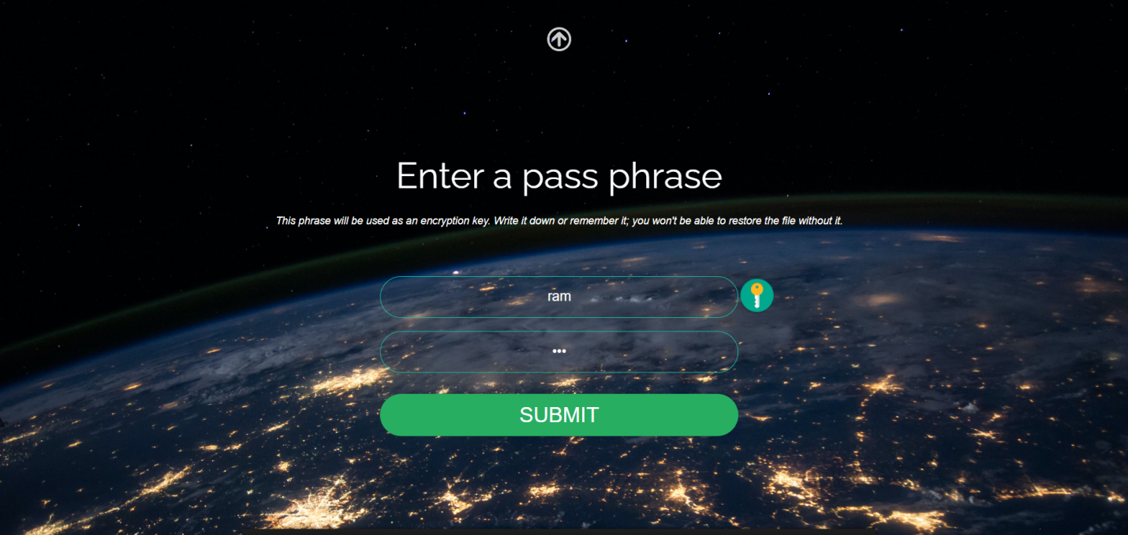





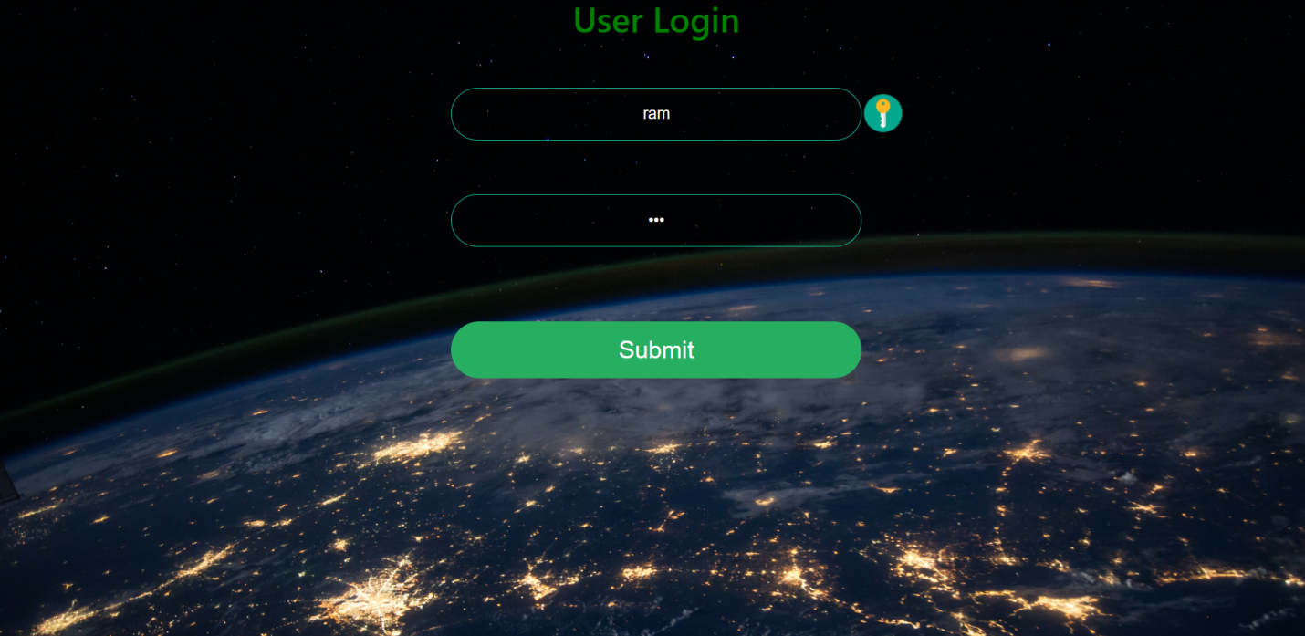

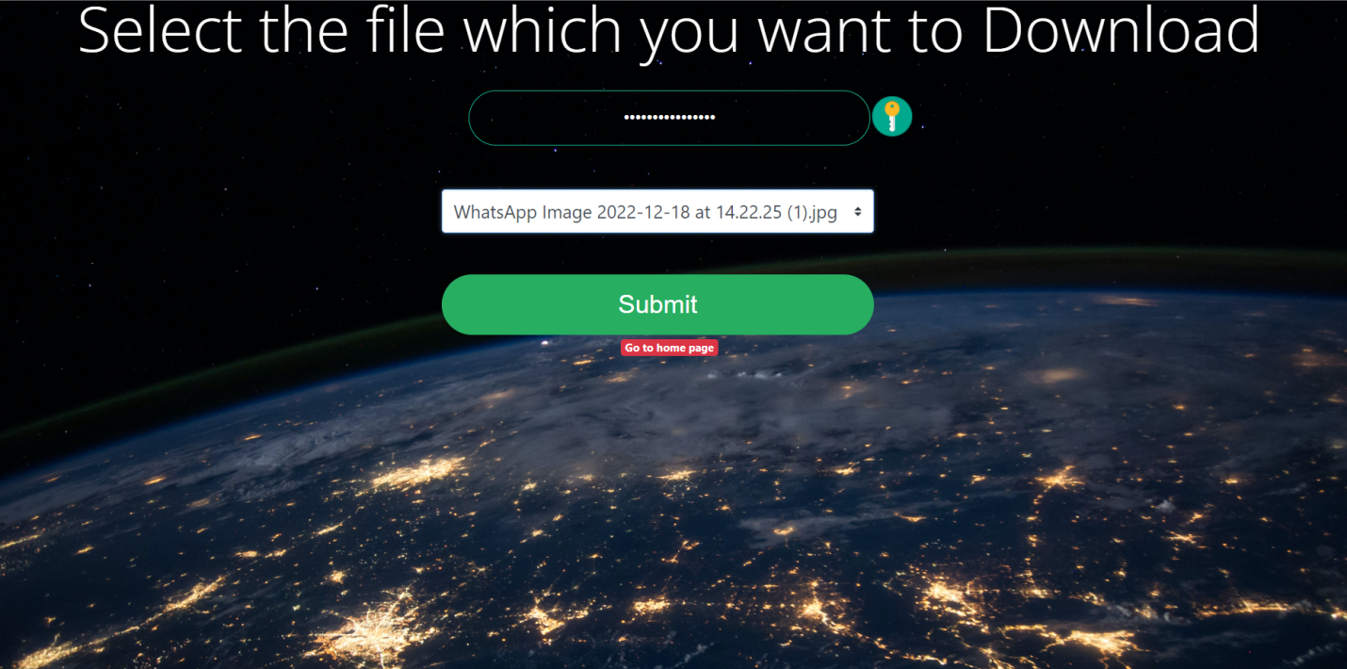

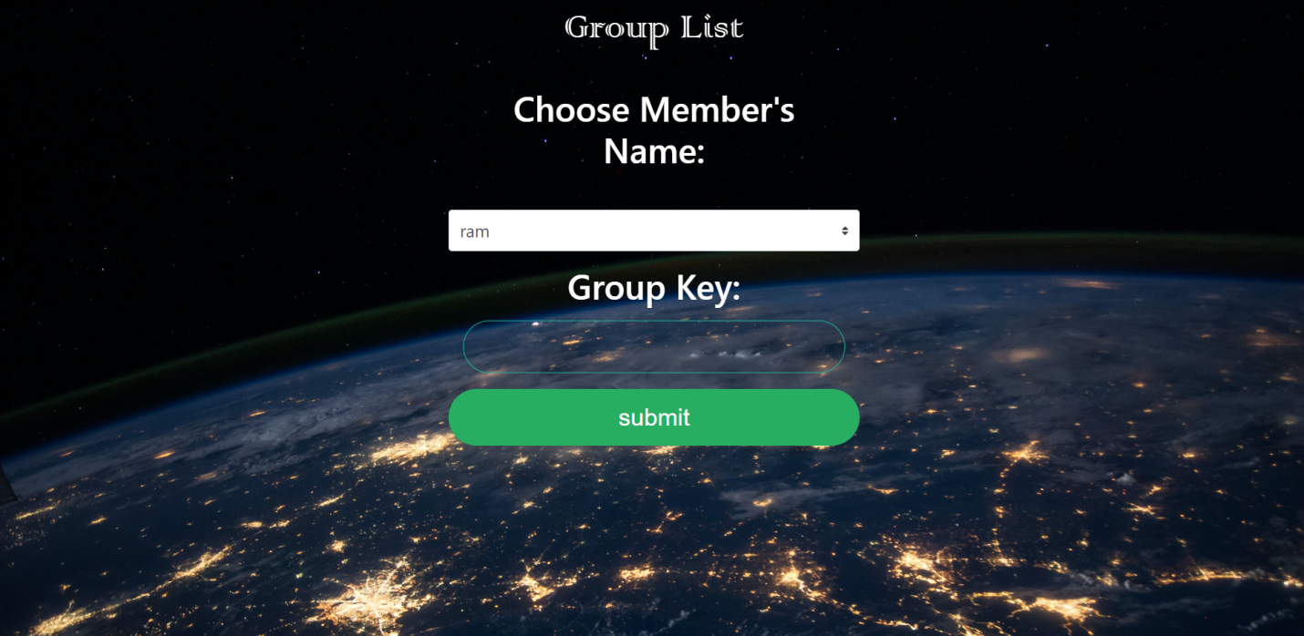

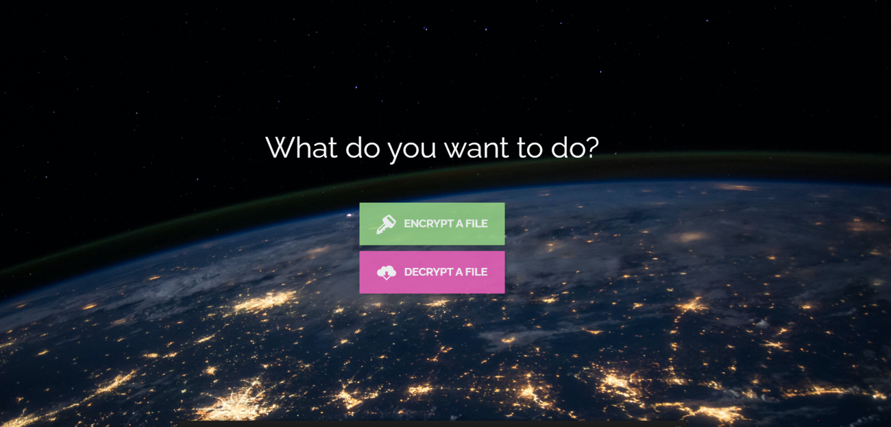

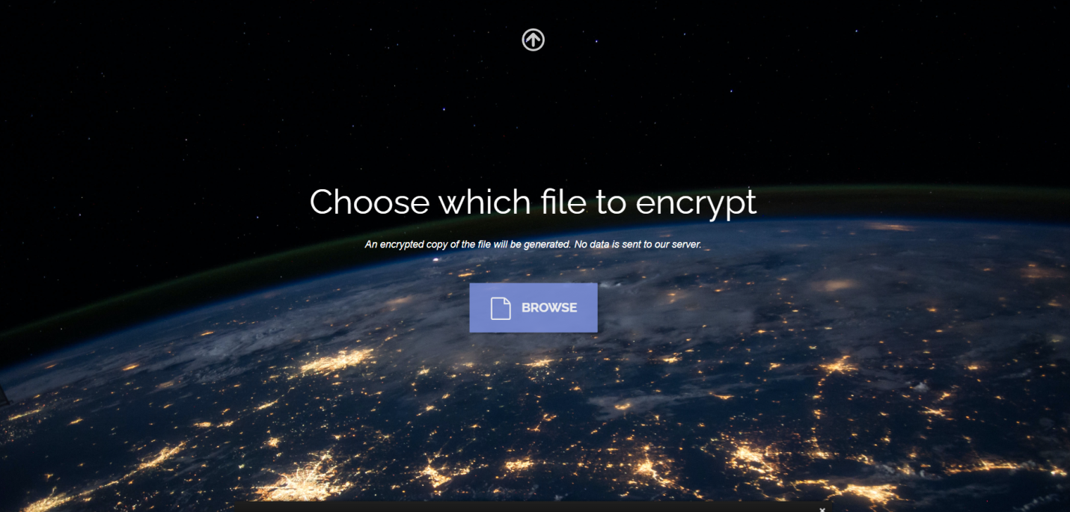

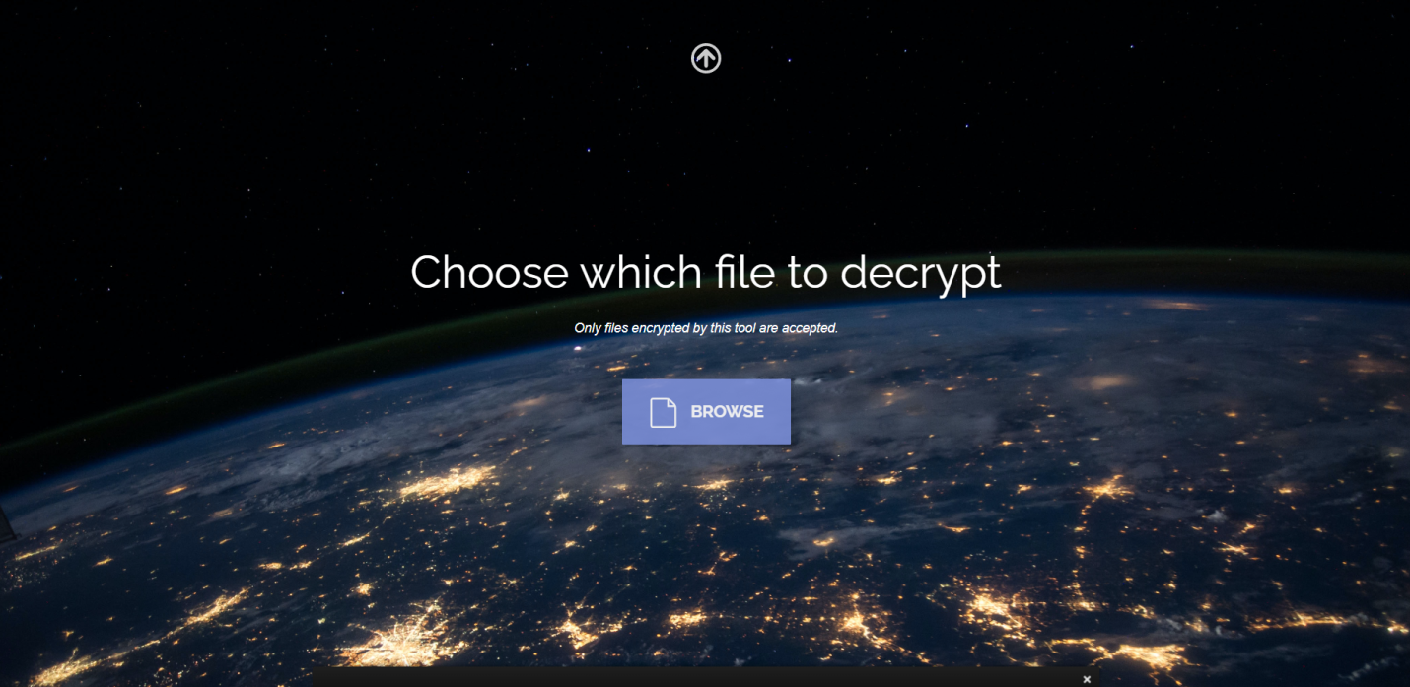

1. **Conclusion:**

Erasure codes are promising for improving the reliability of the storage system due to its space efficiency compared to the replication methods. Traditional erasure codes split data into equalsized data blocks and encode strips in different data blocks. This brings heavy repairing traffic when clients read parts of the data, since most strips read for repairing are not in the expected blocks. This paper proposes a novel discrete data dividing method to completely avoid this problem. The key idea is to encode strips from the same data block. We could see that for repairing failed blocks, the strips to be read are either in the same data block with corrupted strips or from the encoded strips. Therefore, no data is wasted. We design and implement this data layout into a HDFS-like storage system. Experiments over a small-scale testbed shows that the proposed discrete data divided method avoids downloading data blocks that are not needed for clients during the repairing operations.

1. **Future Enhancements**

As a response, [erasure coding](http://searchstorage.techtarget.com/definition/erasure-coding) as an alternative to backup has emerged as a method of protecting against drive failure.[Raid](http://searchstorage.techtarget.com/definition/RAID) just does not cut it in the age of high-capacity HDDs. The larger a disk's capacity, the greater the chance of bit error.And when a disk fails, the [Raid rebuild](http://searchstorage.techtarget.com/definition/RAID-rebuild) process begins, during which there is no protection against a second (or third) mechanism failure. So not only has the risk of failure during normal operation grown with capacity, it is much higher during [Raid rebuild](http://www.computerweekly.com/news/2240213902/BQ-owner-Kingfisher-dumps-Raid-rebuilds-and-saves-40-on-disk-with-X-IO), too. Also, rebuild times were once measured in minutes or hours, but disk transfer rates have not kept pace with the rate of disk capacity expansion, so large Raid rebuilds can now take days or even longer.

1. **REFERENCES:**

[1] James S. Plank, Erasure Codes for Storage Systems A Brief

Primer, *USENIX .login*, Vol. 38 No. 6, 2013.

[2] Hsing-bung Chen, Ben McClelland, et al., An Innovative

Parallel Cloud Storage System using OpenStack’s Swift Object

Store and Transformative Parallel I/O Approach, *Los Alamos*

*National Lab Science Highlights*, 2013.

[3] Corentin Debains, Gael Alloyer, Evaluzation, Evaluation of

Erasure-coding libraries on Parallel Systems, 2010.

[4] Peter Sobe, Parallel Reed/Solomon Coding on Multicore

Processors, in *Proceedings of International Workshop on*

*Storage Network Architecture and parallel I/O*, 2010.

[5] Babak Behzad, Improving parallel I/O auto tuning with

performance modeling, in *Proceedings of ACM International*

*Symposium on High-performance Parallel and Distributed*

*Computing (HPDC)*, 2014.

[6] Hsing-bung Chen, parEC – A Parallel and Scalable of erasure

coding support in Cloud Object Storage Systems, Los Alamos

National Lab.

[7] A. Varbanescu , On the Effective Parallel Programming of

Multi-core Processors, Ph.D Thesis, Technische Universiteit

Delft , 2010.

[8] William Gropp Ewing Lusk, Anthony Skjellum, Using MPI:

Portable Parallel Programming with the Message-Passing

Interface, The MIT Press, 2014.

[9] Hsing-bung Chen, Parallel Workload Benchmark on Hybrid

Storage EcoSystem, Los Alamos national Lab.